
faculty of science helwan University

Department of computer science and (Mathematics | Statistics) Final Year Project

University Management Smart System

By:

- Seif Alaa Eldein Abdelhameid Hemeida
- Abdulrahman Mohammed Mohammed Saeed
- Momen Kamel Ahmed Mohamed
- Aya Ismaiel Abdelghany Naeem
- Naira Magdy Ahmed Fouad
- Aya Hesham Galal Shahat
- Mariem Anwar Abdelkhalek

Supervised By: Dr. Mourad Raafat

Supervisor(s): Date of
examination:

Abstract

This project details the design and implementation of a comprehensive Smart University Management System for Helwan University, developed using ASP.NET Core MVC and Python. The platform seamlessly integrates core university administration functionalities with advanced Artificial Intelligence (AI) features. It introduces a facial recognition-based attendance system that automates student check-ins in real-time, significantly enhancing efficiency and accuracy over traditional manual methods. Furthermore, an AI-powered chatbot is embedded to provide instant, intelligent support to students by answering frequently asked questions and dynamically directing them to personalized information within the portal.

The primary objective was to address critical challenges prevalent in many traditional university systems, such as inefficient manual processes, outdated communication channels, and limited data accessibility. By leveraging modern web technologies, robust database management (SQL Server with Entity Framework Core), and AI, the system aims to streamline operations, reduce administrative overhead, and enrich the student experience. The chatbot utilizes Natural Language Processing (NLP) for intelligent query understanding, while the attendance system employs computer vision for secure identity verification. The platform also integrates external services like Stripe for secure online payments and Cloudinary for efficient file management.

Beyond technical innovation, this system delivers a scalable, secure, and user-centric solution poised to transform educational administration. The final outcome was rigorously evaluated through testing with students, faculty, and administrative staff, yielding highly positive feedback regarding its usability, speed, reliability, and practical value in transitioning towards a digital-first university environment.

Acknowledgement
We would like to express our profound gratitude to our esteemed project supervisor, "Dr/Mourad Raafat", for their invaluable guidance, insightful feedback, and unwavering support throughout every stage of this project. Their profound expertise, inspiring encouragement, and dedicated mentorship have been truly instrumental in navigating challenges, refining our ideas, and ultimately shaping our vision into a successful and impactful outcome.

We extend our sincere appreciation to the Faculty of Science at Helwan University for providing us with the essential infrastructure, cutting-edge resources, and a truly conducive environment that were indispensable for carrying out this extensive research and development. Their steadfast dedication to fostering student innovation, critical thinking, and applied learning has undeniably made this ambitious project possible.

Our heartfelt thanks are also due to all other academic staff members who generously provided invaluable technical advice, insightful suggestions, and constructive criticism that significantly enhanced the quality, efficiency, and overall depth of our work.

We wish to acknowledge the foundational contributions of the organizations and diligent developers behind essential open-source platforms and libraries such as OpenCV, TensorFlow (Keras), NLTK, Flask, NumPy, and Pandas, whose robust tools were absolutely integral to the successful implementation and functioning of our advanced AI systems.

To the dedicated students and faculty members who participated in our rigorous testing sessions, providing invaluable feedback and insights, your time, honesty, and constructive input were crucial in refining our system and ensuring it genuinely meets diverse user needs.

Finally, we express our most heartfelt gratitude to our beloved families and friends for their boundless patience, unwavering motivation, and steadfast emotional support throughout the demanding duration of this project. Your belief in our capabilities and consistent encouragement made this challenging journey remarkably smoother and profoundly more rewarding.

Table of Contents
- Introduction 1-8
  - 1.1 Problem Statement 1
  - 1.2 Project Aim & Objectives 2
  - 1.3 Project Scope 3-4
  - 1.4 Significance / Impact of the Project 5
  - 1.5 System Requirements 6-8
    - 1.5.1 Functional Requirements
    - 1.5.2 Non-Functional Requirements
- Literature Review 9-16
  - 2.1 Overview of Related Systems & Technologies 9-10
  - 2.2 Critique of Existing Solutions & Research Gap 11-12
  - 2.3 Theoretical Background 12-16
- System Analysis & Design 17-46
  - 3.1 System Architecture 17-21
    - 3.1.1 High-Level Architecture Diagram (Component Diagram):
    - 3.1.2 Architectural Layers Description
  - 3.2 User Roles and Permissions 21-23
  - 3.3 Functional Design 23-30
    - 3.3.1 Use Case Diagram
    - 3.3.2 Use Case Descriptions
  - 3.4 Dynamic Behavior 30-33
    - 3.4.1 Key Interaction Flow (Sequence Diagram)
    - 3.4.2 State Lifecycle (State Machine Diagram)
  - 3.5 Database Design 34-38
    - 3.5.1 Entity-Relationship Diagram (ERD)
    - 3.5.2 Database Schema Description
  - 3.6 User Interface (UI) Design Principles & Mockups 38-46

- Implementation 47-58
  - 4.1 Technologies & Tools Used 47-48
  - 4.2 Software Development Details 48-58
    - 4.2.1 Module/Component Implementation Overview
    - 4.2.2 Key Algorithms / Business Logic
    - 4.2.3 Challenges Encountered During Implementation & Their Solutions

- Testing & Evaluation 59-63
  - 5.1 Testing Methodology 59-60
  - 5.2 Test Cases & Results 60-62
  - 5.3 Performance Evaluation 62-63

- Results & Discussion 64-73
  - 6.1 Achieved Functionalities & Demonstration 64-69
  - 6.2 Project Objectives Achievement 70-72
  - 6.3 Discussion of Results & Project Limitations 72-73

Conclusion & Future Work 74-77
  - 7.1 Conclusion 74-75
  - 7.2 Future Work 76-77

- References 78

Chapter 1: Introduction

Problem Statement
Traditional university management systems often struggle with inefficiencies, outdated communication methods, and fragmented data processes, leading to significant challenges for both students and administration. These issues create bottlenecks in daily operations, reduce user satisfaction, and hinder effective decision-making.

Specifically, the project addresses several key problems observed in conventional university environments:

Inefficient Manual Operations: Critical processes such as student attendance recording are often performed manually, making them time-consuming, prone to human error, and difficult to accurately track or analyze. Similarly, managing student data, academic records, and administrative procedures involves extensive paperwork and manual intervention, leading to delays and increased overhead.

Lack of Instant Information Access: Students frequently encounter difficulties in quickly obtaining answers to common queries regarding their academic performance, course schedules, departmental information, or administrative guidelines. This often necessitates physical visits or lengthy communication delays, impacting student experience.

Limited Data Insights and Decision-Making: The absence of integrated and intelligently processed data restricts the university's ability to gain meaningful insights into academic trends, student progress, or operational efficiency. This hinders data-driven strategic planning and resource allocation for continuous improvement.

Outdated Communication Channels: Reliance on traditional methods for disseminating important news, updates, or alerts can lead to information lags and reduce overall responsiveness within the university community.

This project, therefore, aims to develop a comprehensive, intelligent, and efficient platform that integrates modern web technologies with advanced Artificial Intelligence capabilities. This approach is essential to overcome the limitations of current systems, enhance operational fluidity, provide immediate support, and improve data accessibility for all stakeholders within Helwan University.

Project Aim & Objectives
This project aims to address the identified inefficiencies and challenges within traditional university management systems by introducing a modern, intelligent, and integrated web-based platform.

Overall Aim
The overarching goal of this project is to develop a comprehensive, intelligent, and highly efficient web-based management platform for Helwan University, seamlessly integrating core administrative and academic functionalities with advanced Artificial Intelligence capabilities to enhance operational efficiency, data accessibility, and the overall user experience for all stakeholders.

Specific Objectives
To achieve this overarching aim, the project focuses on the following specific and measurable objectives:
- To automate and enhance student attendance tracking: By designing and implementing an AI-powered facial recognition-based attendance system, ensuring real-time recording and improved accuracy.
- To provide instant and intelligent student support: Through the development and integration of an AI-driven chatbot capable of answering frequently asked questions and dynamically directing students to personalized information within the university portal.
- To streamline core academic and administrative operations: Including efficient management of student profiles, academic records, subjects, departments, and faculties.
- To enhance data accessibility and analytical capabilities: By centralizing university data and providing intuitive reporting tools for improved administrative insights and strategic decision-making.
- To integrate secure online payment solutions: By implementing a robust payment gateway (Stripe) for tuition fees, simplifying financial transactions for students and the administration.

Project Scope
The scope of the Helwan University Smart Management System project defines the boundaries of its functionalities, covered user types, and the technologies integrated. This clarifies what the current system encompasses and what falls outside its initial development phase.

Included in Scope:
Core University Administration Modules: The system provides robust functionalities for managing essential university data, including:

- Student profiles, academic records, and progression.
- Faculty and department details.
- Subject management and assignment to departments and doctors.
- High-Board member profiles and their roles (e.g., President, Deans, Heads of Departments).
- AI-Powered Attendance System: The project includes an automated attendance system utilizing facial recognition technology to record student presence in real-time. This system is integrated with the main web application's database for seamless data flow and storage.
- Intelligent AI Chatbot: An integrated chatbot is provided to offer instant support to students. It is designed to answer general university-related queries and provide dynamic links to specific, personalized information (e.g., grades, personal profile) within the web portal.
- Secure Online Payment Integration: The system integrates a third-party payment gateway (Stripe) to facilitate secure online tuition fee payments for students.
- Role-Based Access Control: Comprehensive authorization mechanisms are implemented, ensuring that different user types (System Admin, High-Board Member, Doctor, Student, Public User) have distinct and appropriate access levels and functionalities.
- Activity Logging: The system logs critical user actions for auditing and security purposes, recording details of operations performed by administrators, faculty, and students.
- Basic Reporting & Data Visualization: The platform includes functionalities to generate and display basic academic reports and visual data insights (e.g., GPA statistics, attendance summaries) for administrative and faculty use.
- Web-Based Platform: The primary interface for the system is a web application accessible via standard web browsers.

Excluded from Scope (for the current version):
- Mobile Application Development: A dedicated native mobile application for iOS or Android is not part of this project's initial scope. All interactions occur through the web platform.
- Advanced AI Features: While core AI functionalities are integrated, highly advanced AI features such as predictive analytics for student performance, automated scheduling, or complex sentiment analysis for chatbot interactions are beyond the current scope.
- Comprehensive Liveness Detection: The AI attendance system's initial implementation focuses on facial recognition accuracy. Advanced anti-spoofing or deep liveness detection mechanisms are considered future work.
- Real-time Communication (beyond Chatbot): Features like real-time notifications (e.g., push notifications), live video conferencing, or collaborative workspaces are not included.
- External System Integration (beyond core): Integration with other external university systems (e.g., Learning Management Systems (LMS) like Moodle, external HR systems) is not part of the current scope.
- Complex Financial Accounting: The payment integration handles tuition fees; a full-fledged financial accounting system for the university is outside the project's scope.

Significance / Impact of the Project
The Helwan University Smart Management System is poised to deliver a substantial positive impact on various aspects of university operations and the overall stakeholder experience. By addressing critical inefficiencies inherent in traditional systems, this project offers significant contributions:
- Enhanced Operational Efficiency and Automation: The integration of an AI-powered facial recognition attendance system drastically automates the tedious and error-prone manual attendance procedures. This leads to significant time savings for faculty and administrative staff, allowing them to focus on more strategic tasks. Streamlined management of academic records, student profiles, and departmental data further reduces administrative overhead and improves workflow efficiency.
- Improved Student Experience and Engagement: The intelligent AI chatbot provides instant, 24/7 support for students, offering quick answers to frequently asked questions and dynamically guiding them to personalized information such as grades and academic records. This immediacy of information access significantly enhances student satisfaction and reduces frustration associated with traditional communication channels.
- Data-Driven Decision-Making: By centralizing university data and providing intuitive reporting and visualization tools, the system empowers administration and faculty with actionable insights into academic performance, attendance patterns, and resource utilization. This facilitates more informed strategic planning and allows for proactive interventions to support student success and optimize departmental operations.
- Enhanced Security and Data Integrity: The adoption of AI for facial recognition in attendance provides a more secure and reliable method of student verification. Coupled with robust role-based access control, the system ensures that sensitive university data is protected, and interactions are authenticated and authorized according to user roles. Activity logging further contributes to accountability and audit trails.
- Modernization and Digital Transformation: The project propels Helwan University towards a digital-first environment by embracing advanced technologies like AI, cloud-based file management (Cloudinary), and secure online payment processing (Stripe). This modernization not only improves current operations but also positions the university as an innovator in educational administration.
- Scalability and Adaptability: The modular and layered architecture of the system ensures its scalability to accommodate future growth in student numbers and data volume, while also allowing for the integration of new features and technologies with relative ease.
In essence, the Helwan University Smart Management System acts as a catalyst for a more efficient, user-centric, and technologically advanced educational environment, directly contributing to the university's mission of academic excellence and student well-being

System Requirements
This section details the functional and non-functional requirements that define the core capabilities and quality attributes of the Helwan University Smart Management System.

Functional Requirements
The system shall perform the following specific functions, categorized by user role:

User & Authentication Management:
        - The system shall allow users to register, log in, and log out securely.
        - The system shall support role-based authentication and authorization for Admin, High-Board, Doctor, and Student roles.
        - The system shall allow users to change their passwords.

Administrator (Admin) Specific Functions:
        - The system shall allow administrators to manage (add, view, edit, delete) student profiles, including personal and academic details.
        - The system shall allow administrators to manage (add, view, edit, delete) doctor profiles and their associated user accounts.
        - The system shall allow administrators to manage (add, view, edit, delete) High-Board member profiles and their associated user accounts.
        - The system shall allow administrators to manage (add, view, edit, delete) faculties, departments, and subjects.
        - The system shall allow administrators to manage the assignment of subjects to departments.
        - The system shall allow administrators to manage public files (images, videos) displayed on the university website.
        - The system shall allow administrators to update general university information (e.g., contact details, social media links).
        - The system shall provide access to comprehensive system activity logs.
        - The system shall enable administrators to generate and export various reports, including student fees status.

High-Board Member Specific Functions (Deans, Heads of Departments, VPs):
        - The system shall allow High-Board members to view their specific faculty/department details.
        - The system shall allow High-Board members to view student profiles and academic records relevant to their faculty/department.
        - The system shall allow High-Board members to manage (add/remove) subjects within their respective departments/faculties.
        - The system shall allow High-Board members to record and update student grades for subjects under their authority.
        - The system shall provide High-Board members with access to departmental academic reports and GPA statistics.
        - The system shall allow High-Board members to manage their profile picture.

Doctor Specific Functions:
        - The system shall allow doctors to view their assigned subjects.
        - The system shall allow doctors to record and update student grades for their specific subjects.
        - The system shall allow doctors to view student profiles and academic records for students enrolled in their subjects.
        - The system shall allow doctors to manage their profile picture.

Student Specific Functions:
        - The system shall allow students to view their personal profile details and academic records (grades, GPA, credit hours, academic level, semester).
        - The system shall allow students to enroll in and unenroll from subjects based on their academic progress and department affiliation.
        - The system shall allow students to process online tuition fee payments via an integrated payment gateway.
        - The system shall provide students with an intelligent chatbot for instant support and redirection to relevant information pages.
        - The system shall allow students to view their tuition fees status.
        - The system shall allow students to manage their profile picture.

Public User Specific Functions:
        - The system shall allow public users to view general university information, faculty details, news, and maps without authentication.

AI Attendance System Specific Functions:
        - The system shall automatically record student attendance using facial recognition upon detection by the AI attendance device.
        - The system shall accurately identify registered students and log their attendance directly into the main database.
        - The system shall store high-quality facial images for training and identification purposes.

Non-Functional Requirements

The system shall adhere to the following quality attributes:

Performance:
        - The system shall provide fast response times for web pages and API calls (e.g., typical page load time under 3 seconds, API response times under 500ms for common operations).
        - The AI attendance system shall perform facial recognition and record attendance in near real-time, with minimal latency.
        - Database queries, especially for reporting and dashboards, shall be optimized to ensure efficient data retrieval.

Security:
        - The system shall implement robust authentication and authorization mechanisms (ASP.NET Core Identity).
        - All sensitive data transmission (e.g., passwords, personal information, payment details) shall be secured using HTTPS.
        - The system shall prevent unauthorized access to data and functionalities based on user roles and specific permissions.
        - The system shall log critical user activities and system events for auditing purposes.
        - The AI attendance system shall be designed with considerations for anti-spoofing measures (as future work).

Usability:
        - The system shall feature an intuitive and user-friendly interface that is easy to navigate for all user roles.
        - The chatbot shall provide clear, concise, and helpful responses to student queries.
        - The system shall provide clear feedback to users on the status of operations (e.g., success messages, error notifications).

Scalability:
        - The system architecture shall support an increasing number of users (students, faculty, staff) and growing data volumes without significant degradation in performance.
        - The use of cloud services (Cloudinary) shall support scalable storage for files.
        - The modular design shall allow for future expansion and addition of new features or integration with other systems.

Reliability:
        - The system shall maintain consistent functionality and availability.
        - Error handling mechanisms shall be robust to prevent system crashes and provide informative feedback to users.
        - Data stored in the database shall maintain integrity and consistency.

Maintainability:
        - The codebase shall be well-structured, modular, and documented for ease of future modifications and updates.
        - Adherence to software design patterns (e.g., Repository Pattern, Dependency Injection) shall promote maintainability.

Chapter 2: Literature Review

Overview of Related Systems & Technologies
The development of the Helwan University Smart Management System draws upon various established and emerging technologies crucial for modernizing university operations. This section provides an overview of the key related systems and technologies that form the foundation and context of our project.

University Management Systems (UMS)
Traditional University Management Systems are comprehensive platforms designed to handle the core administrative, academic, and financial operations of higher education institutions.
These systems typically manage student admissions, registration, academic records, course scheduling, faculty information, and financial transactions. While essential, many legacy UMS platforms often face challenges such as:
      - Reliance on manual processes for certain tasks.
      - Fragmented data across different modules.
      - Limited capabilities for real-time analytics and intelligent decision-making.
      - Outdated user interfaces and communication methods.
Modern UMS trends focus on integration, data centralization, and enhancing user experience, often incorporating web-based access and mobile functionalities. Our project aims to extend these modern trends by embedding advanced AI capabilities.

AI Attendance Systems
AI-powered attendance systems leverage artificial intelligence, particularly computer vision and machine learning, to automate the process of recording presence. Unlike traditional methods (manual roll calls, ID card swiping, or biometric fingerprint scanners), AI attendance systems based on facial recognition offer:
      - Automation: Eliminating the need for manual intervention during check-in.
      - Efficiency: Speeding up the attendance process.
      - Accuracy: Reducing human error and buddy punching.
      - Security: Providing a unique, non-transferable method of identification.
These systems typically involve capturing an image or video stream, detecting faces, extracting unique facial features (encodings), and comparing them against a database of known individuals for identification. Technologies like Convolutional Neural Networks (CNNs) are foundational for face detection and recognition, with techniques like Transfer Learning often used to adapt pre-trained models for specific tasks. Our project integrates such a system to provide real-time, automated attendance logging for students.

Chatbot
Chatbots are AI programs designed to simulate human conversation through text or voice interfaces. They are increasingly deployed in various sectors, including customer service, healthcare, and education, to provide instant support and information. Chatbots can be broadly categorized into:
      - Rule-Based Chatbots: Follow predefined rules and scripts to respond to specific keywords or phrases. They are effective for Frequently Asked Questions (FAQs) but lack flexibility.
      - AI-Powered / Generative Chatbots: Utilize Natural Language Processing (NLP) and Machine Learning (ML) models to understand user intent, extract information, and generate more natural, context-aware responses. Advanced models often employ techniques like Retrieval-Augmented Generation (RAG) to fetch information from a knowledge base before generating a response, providing more accurate and relevant answers.
In a university context, chatbots can significantly reduce the administrative burden by handling routine inquiries, providing quick access to information, and guiding users to relevant resources. Our project's chatbot is designed to offer intelligent student support by answering questions and directing students to specific pages within the university portal.

Online Payment Gateways
Online payment gateways are crucial components of e-commerce and digital service platforms, enabling secure financial transactions over the internet. They act as intermediaries between the customer, the merchant, and the bank, facilitating the authorization of credit card or other payment methods. Key aspects of online payment gateways include:
      - Security: Employing encryption and fraud detection mechanisms to protect sensitive financial data.
      - Compliance: Adhering to industry standards like PCI DSS.
      - Integration: Providing APIs that allow seamless integration with web and mobile applications.
For universities, online payment gateways simplify tuition fee collection, provide convenience for students and parents, and enhance financial transparency and record-keeping. Our system integrates a robust payment gateway (Stripe) to offer a secure and streamlined process for students to pay their fees online.

Critique of Existing Solutions & Research Gap
While existing university management systems and standalone solutions offer various functionalities, they often present a fragmented landscape, falling short in providing a truly integrated, intelligent, and user-centric experience. A critical analysis of these current solutions reveals significant weaknesses, thereby highlighting the specific research gap that the Helwan University Smart Management System aims to address.

Strengths and Weaknesses of Current Solutions
Strengths:
      - Established Core Functionalities: Traditional University Management Systems (UMS) provide foundational capabilities for student enrollment, academic record keeping, and basic administrative tasks.
      - Specialized Automation: Standalone AI attendance systems and basic chatbots can automate specific processes, reducing some manual effort.
      - Payment Convenience: Online payment gateways offer secure and convenient financial transaction processing.
Weaknesses:
      - Lack of Integration and Fragmentation: A primary weakness is the common disjunction between different university systems. Data often resides in silos, requiring manual transfers between disparate modules (e.g., attendance data separate from academic records, student information separate from communication tools). This leads to data inconsistency, redundancy, and significant administrative overhead.
      - Over-reliance on Manual Processes: Despite technological advancements, many universities still depend heavily on manual procedures for critical operations like attendance tracking and certain aspects of student support. These manual processes are inherently inefficient, time-consuming, and highly susceptible to human error.
      - Limited Intelligence and Proactive Support: Traditional systems typically lack embedded intelligent capabilities. Students often experience delays in receiving information or support, as chatbots, if present, are usually rule-based and unable to provide personalized or dynamic responses linked to their academic profiles.
      - Suboptimal User Experience: Outdated interfaces, complex navigation, and the absence of intuitive self-service options contribute to a less engaging and user-friendly experience for students, faculty, and administrative staff.
      - Scalability and Adaptability Challenges: Legacy systems can struggle to scale with increasing student populations or adapt quickly to evolving educational needs and technological advancements, often requiring costly and time-consuming upgrades.

The Research Gap
The identified weaknesses reveal a critical gap in the existing solutions: the absence of a unified, intelligently integrated, and user-centric platform that comprehensively addresses the multifaceted needs of a modern university. Current systems either provide fragmented functionalities or lack the embedded AI capabilities necessary for true automation, real-time interaction, and data-driven insights.
This project specifically addresses this gap by:
      - Holistic Integration: Unifying core university management functionalities with advanced AI features (facial recognition attendance and an intelligent chatbot) and essential external services (online payments, cloud storage) into a single, seamless web platform.
      - Intelligent Automation: Moving beyond mere digitization to intelligent automation, particularly in attendance tracking, which transforms a manual, error-prone process into an efficient, real-time, and secure operation.
      - Proactive and Personalized Student Engagement: Providing an AI chatbot that not only answers general questions but also intelligently guides students to personalized information by generating dynamic links, thereby fostering greater self-sufficiency and immediate support.
      - Enhanced Decision-Making: Centralizing disparate data streams and offering integrated analytics tools, enabling the university administration to derive meaningful insights for strategic planning and operational optimization.
By focusing on this intelligent integration and comprehensive automation within a user-friendly platform, the Helwan University Smart Management System offers a distinct and advanced solution that surpasses the capabilities of many existing fragmented or less intelligent university management tools.

Theoretical Background
The Helwan University Smart Management System is built upon a foundation of several core theoretical concepts and advanced technological paradigms. Understanding these principles is crucial for comprehending the design, implementation, and functionality of the integrated platform. This section outlines the fundamental theoretical backgrounds underpinning the project.

ASP.NET Core MVC
ASP.NET Core MVC (Model-View-Controller) is a modern, open-source, and cross-platform framework for building web applications and APIs using the C# programming language. It implements the Model-View-Controller architectural pattern, which separates the application into three interconnected components:

      - Model: Represents the application's data, business logic, and rules. In our system, this includes entities like Student, Subject, Doctor, and AttendanceRecord.
      - View: Responsible for presenting the user interface, displaying data to the user. In our project, these are Razor Views (.cshtml files).
      - Controller: Handles user input, interacts with the Model, and selects the appropriate View to render. It acts as the intermediary between the Model and View. ASP.NET Core MVC provides features such as routing, model binding, validation, and dependency injection, which contribute to building robust, scalable, and maintainable web applications.

Object-Oriented Programming (OOP)

Object-Oriented Programming (OOP) is a programming paradigm based on the concept of "objects" which can contain data (attributes) and code (methods) that operate on that data. OOP's main principles include:

      - Encapsulation: Bundling data and methods that operate on the data within a single unit (class), hiding the internal details.
      - Inheritance: Allowing a new class (subclass) to inherit properties and behaviors from an existing class (superclass), promoting code reuse.
      - Polymorphism: The ability of objects of different classes to be treated as objects of a common superclass, allowing methods to behave differently based on the object type.
      - Abstraction: Hiding complex implementation details and showing only the essential features of an object. Our system leverages OOP principles extensively in its C# codebase, where models, repositories, and services are designed as classes with encapsulated logic and defined interfaces, enhancing modularity, maintainability, and extensibility.

Database Management Systems (DBMS)
Database Management Systems (DBMS) are software systems used to define, manipulate, retrieve, and manage data in a structured manner. Relational Database Management Systems (RDBMS) organize data into tables, with relationships defined between them using primary and foreign keys. Key aspects include:

      - Data Integrity: Ensuring the accuracy and consistency of data over its entire life cycle.
      - Concurrency Control: Managing simultaneous access to the database by multiple users to prevent conflicts.
      - Security: Protecting data from unauthorized access and modifications.
      - Backup and Recovery: Mechanisms for data protection and restoration. Our system utilizes SQL Server as its robust relational database backend, ensuring reliable storage and management of all university-related data, including student records, attendance logs, and administrative information.

Object-Relational Mapping (ORM - Entity Framework Core)

      - Object-Relational Mapping (ORM) is a programming technique that converts data between incompatible type systems using object-oriented programming languages. An ORM library typically creates a "virtual object database" that can be used from within the programming language. Key benefits include:

      - Abstraction: Developers can interact with database records as programming language objects, abstracting away complex SQL queries.
      - Productivity: Speeds up development by reducing the need to write repetitive data access code.
      - Portability: Some ORMs allow switching between different database systems with minimal code changes. Entity Framework Core (EF Core) is a popular, open-source ORM framework for .NET applications. It enables developers to work with a database using .NET objects, eliminating the need for most of the data-access code that developers typically write. In our project, EF Core manages the interaction between our C# application models and the SQL Server database, facilitating efficient data persistence and retrieval through LINQ queries.

Natural Language Processing (NLP)

Natural Language Processing (NLP) is a subfield of Artificial Intelligence (AI) that focuses on enabling computers to understand, interpret, and generate human language. Key NLP tasks include:

      - Tokenization: Breaking text into smaller units (words, sentences).
      - Lemmatization/Stemming: Reducing words to their base or root form.
      - Part-of-Speech Tagging: Identifying the grammatical role of words.
      - Intent Recognition: Determining the user's underlying goal or purpose from their query. Our chatbot leverages NLP techniques (specifically using NLTK) to process student queries, understand their intent, and extract relevant information, enabling it to provide accurate and contextually appropriate responses.

Machine Learning (ML) for Classification

Machine Learning (ML) is a subset of AI that allows systems to learn from data without explicit programming. Classification is a common ML task where algorithms learn from labeled training data to categorize new, unseen observations into predefined classes or groups.

- Supervised Learning: A type of ML where the model is trained on labeled datasets (input-output pairs) to predict outputs for new inputs. Classification often falls under supervised learning.
- Deep Learning (DL): A subset of ML that uses neural networks with multiple layers (deep neural networks) to learn complex patterns from data. Convolutional Neural Networks (CNNs) are a type of deep learning model particularly effective for image processing tasks. In our project, ML (specifically SVM from Scikit-learn and potentially aspects of deep learning models in face recognition) is applied for facial recognition, where the system classifies detected faces to identify specific students based on their trained facial encodings.

RESTful APIs
REST (Representational State Transfer) is an architectural style for building web services. RESTful APIs (Application Programming Interfaces) use standard HTTP methods (GET, POST, PUT, DELETE) to interact with resources (data) identified by URLs. Key characteristics include:

      - Statelessness: Each request from a client to a server contains all the information needed to understand the request.
      - Client-Server Architecture: Separation of concerns between client and server.
      - Uniform Interface: Standardized methods and resource identification. Our system extensively uses RESTful APIs to facilitate communication between its different components (e.g., ASP.NET Core backend and Python AI services for attendance and chatbot) and with external services (like Stripe).

Cloud Computing
Cloud Computing is the on-demand delivery of computing services—including servers, storage, databases, networking, software, analytics, and intelligence—over the Internet ("the cloud").
Instead of owning computing infrastructure or data centers, users can access services from a cloud provider. Key benefits include:

      - Scalability: Resources can be easily scaled up or down based on demand.
      - Cost-Effectiveness: Pay-as-you-go models reduce upfront infrastructure investments.
      - Accessibility: Services are accessible from anywhere with an internet connection.
      - Reliability: Cloud providers offer high availability and disaster recovery. Our project leverages cloud computing by integrating Cloudinary for scalable and efficient cloud storage of university images and files (e.g., student pictures, faculty logos), abstracting the complexity of local file management and serving.

Chapter 3: System Analysis & Design

System Architecture

The Helwan University Smart Management System is designed with a modular, layered, and distributed architecture to ensure scalability, maintainability, and extensibility. This section details the high-level components of the system and their interactions.

High-Level Architecture Diagram (Component Diagram):

The system's high-level architecture, as illustrated in Figure 3.1 (Component Diagram), delineates the main building blocks and their interdependencies. It showcases how various internal components and external services collaborate to deliver a unified intelligent university management solution.
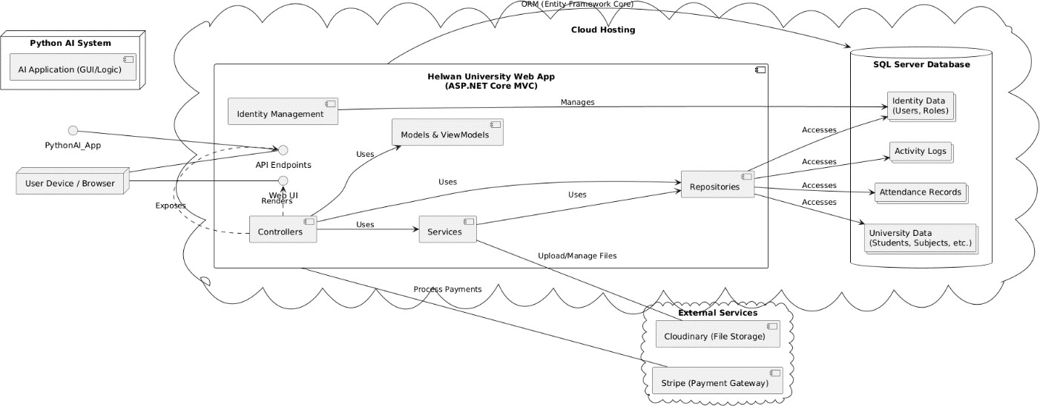
Figure 3.1: High-Level System Architecture (Component Diagram)

The system comprises the following main components:

- Helwan University Web Application (ASP.NET Core MVC App): This serves as the central hub of the system, responsible for user interaction, business logic, and API exposure.
  - Web UI (User Interface): Provides the graphical interface through which students, faculty members, and administrators interact with the system. This includes various portals tailored to different user roles.
  - API Endpoints: Exposes RESTful APIs that allow both internal components and external services to communicate securely with the application's backend.
  - Controllers: Handle incoming HTTP requests, process user input, and orchestrate interactions between models, services, and repositories to deliver responses or render views.
  - Services: Encapsulate business logic and provide a layer of abstraction for complex operations, often interacting with multiple repositories.
  - Repositories: Abstract data access logic, providing a clean interface for controllers and services to interact with the database without direct knowledge of ORM or SQL.
  - Models & ViewModels: Define the data structures for the application (Models map to database entities, while ViewModels are optimized for UI display and data transfer).
  - Identity Management: Handles user authentication, authorization, and role management using ASP.NET Core Identity.
- SQL Server Database: This relational database serves as the persistent storage for all university-related data, including student records, academic information, faculty details, attendance logs, and user credentials. Entity Framework Core (ORM) is utilized to manage object-relational mapping between the application and the database.
- Python AI System: This external system hosts the intelligent components responsible for advanced functionalities.
  - AI Application (GUI/Logic): Specifically, the AI Attendance System, which uses computer vision and machine learning (e.g., face_recognition, scikit-learn) to process real-time video feeds, identify students, and record their attendance automatically. This component communicates with the Web Application's API endpoints.
- Chatbot Service (Python Flask): This is another external Python-based service. It receives natural language queries from the Web Application's API, processes them using NLP and ML models (e.g., NLTK, Keras/TensorFlow, potentially integrating with LLMs like Gemini Flash), and generates intelligent responses or dynamic links back to the web application.

- External Services: The system integrates with third-party cloud-based services to offload specialized functionalities.
  - Cloudinary (File Storage): Provides a scalable and efficient solution for storing and managing digital assets such as student profile pictures, faculty logos, and other university files.
  - Stripe (Payment Gateway): Facilitates secure and compliant online processing of tuition fee payments, providing a convenient method for students to manage their financial obligations.

This architecture ensures a clear separation of concerns, promotes modular development, and supports the integration of diverse technologies to create a robust and intelligent university management solution.

Architectural Layers Description:

The Helwan University Smart Management System is built upon a well-defined layered architecture, a common software design pattern that promotes separation of concerns, modularity, and maintainability. This structure divides the application into distinct logical and physical layers, each with specific responsibilities.

Presentation Layer

Role: This is the topmost layer responsible for the user interface (UI) and handling user interactions. Its primary function is to present data to the user and translate user actions into requests for the lower layers.

Components: In our ASP.NET Core MVC application, this layer primarily comprises:

Views (.cshtml files): These are responsible for rendering the HTML, CSS, and client-side JavaScript to display the user interface.

Controllers: While also part of the Business Logic layer, Controllers in the Presentation context receive HTTP requests from the client, interpret them, and select the appropriate view to render after data processing by deeper layers.

Interaction: It receives user input through web forms and interactive elements, displays information fetched from the Business Logic Layer, and manages the overall user experience.

Business Logic / Services Layer

Role: This layer encapsulates the core business rules, processes data according to application logic, and orchestrates operations between the Presentation Layer and the Data Access Layer. It defines how the system behaves and manages the flow of data.

Components: Services (e.g., ICloudinaryService, IActivityLogger, CloudinaryService, ActivityLogger): These classes contain the specific business rules, calculations (like GPA in IStudentSubjectsRepository's implementation), and coordination logic. They can interact with multiple repositories and external services.

Controllers: Beyond handling presentation, Controllers also contain business logic for validation, authorization ([Authorize] attributes), and orchestrating calls to services and repositories. They decide which business operations to perform based on user requests.

Interaction: Receives requests from the Presentation Layer, applies business rules, performs validations, manipulates data objects, and calls methods in the Data Access Layer to retrieve or persist data. It also integrates with external services like Cloudinary and Stripe.

Data Access / Repositories Layer

Role: This layer provides an abstract interface for accessing and managing data stored in the database. Its main purpose is to isolate the Business Logic Layer from the complexities and specifics of the underlying data storage technology (SQL Server).

Components: Repository Interfaces (e.g., IStudentRepository, ISubjectRepository, IAttendanceRecordRepository): These define the contract of data operations, specifying what data access functionalities are available.

Repository Implementations (e.g., StudentRepository, SubjectRepository, AttendanceRecordRepository): These classes implement the defined interfaces, containing the actual code (using Entity Framework Core) to perform CRUD (Create, Read, Update, Delete) operations and complex data retrieval queries against the database.

ApplicationDbContext: This is the central class in Entity Framework Core that represents the database session and provides DbSet properties for each entity (Model), enabling LINQ queries to interact with the database.

Interaction: Receives data access requests from the Business Logic Layer (e.g., "get all students," "save new attendance record"), translates them into database operations (SQL queries via EF Core), and returns data objects.

Data Layer

Role: This is the lowest layer, primarily responsible for defining the structure of the application's data and how it maps to the physical storage (database tables). It represents the raw data model of the application.

Components: Models (Entities - e.g., Student, Department, Subject, AttendanceRecord, ApplicationUser): These C# classes define the structure of the data, their properties, and the relationships between them. They directly correspond to the tables in the SQL Server database.

ApplicationDbContext (Model Configuration): Contains the OnModelCreating method where Entity Framework Core's Fluent API is used to configure complex relationships, table mappings, data types, and behaviors (like OnDeleteBehavior, HasComputedColumnSql).

Interaction: This layer is passive; it holds the data and its schema, which is then accessed and manipulated by the Data Access Layer.

User Roles and Permissions

Effective management of a university system necessitates a robust user access control mechanism, defining who can access what functionalities and data. The Helwan University Smart Management System implements a comprehensive role-based authorization model using ASP.NET Core Identity, ensuring secure and appropriate access for diverse users.

Description of Actors/Roles

The system interacts with several distinct types of users, each with specific responsibilities and access privileges:

System Administrator (Admin):
  - Role: The super-user with full control over the entire system.
  - Responsibilities: Manages all core entities (students, faculty members, doctors, high-board members, departments, subjects, public files), user accounts, roles, and system-wide configurations. Accesses comprehensive reports and activity logs.
  - System Interaction: Directly interacts with management modules (e.g., Admin.DepartmentController, Admin.StudentController, Admin.FacultyController).

High-Board Member:
  - Role : Represents university leadership and decision-makers, often with specific hierarchical responsibilities. This category includes specialized roles:
    - Dean of Faculty (JobTitle.DeanOfFaculty): Manages specific faculties, their departments, and subjects within that faculty's scope. Can view students and academic data within their faculty.
    - Head of Department (JobTitle.HeadOfDepartment): Manages specific departments and subjects belonging to that department. Can view students and academic data within their department.
    - VP for Finance (JobTitle.VP_For_Finance): Primarily responsible for financial oversight, including viewing tuition fee statuses and related reports.
    - President / Vice President (JobTitle.President, JobTitle.VicePrecident): General leadership roles with broad viewing capabilities.
  - Responsibilities: Oversee academic and administrative processes within their domain, manage relevant entities, and access tailored reports.
  - System Interaction: Interacts primarily through the Doctors area controllers (e.g., Doctors.DepartmentController, Doctors.FacultyController, Doctors.StudentSubjectsController) with specific authorization logic based on their JobTitle and associated Faculty or Department IDs.

Doctor Member:
  - Role: Academic staff responsible for teaching subjects and interacting with students.
  - Responsibilities: Views their assigned subjects, manages (records/updates) grades for students in their subjects, and views student profiles/academic records relevant to their classes. Participates in AI-based attendance recording.
  - System Interaction: Interacts through the Doctors area controllers (e.g., Doctors.DoctorController, Doctors.StudentSubjectsController, Doctors.SubjectController), with authorization ensuring access only to their own profile or data relevant to their taught subjects.

Student:
  - Role: Enrolled individuals participating in academic programs.
  - Responsibilities: Views their personal profile, academic records (grades, GPA, progression), enrolls in subjects, processes tuition payments, and interacts with the AI chatbot for support.
  - System Interaction: Interacts through the Students area controllers (e.g., Students.StudentController, Students.DepartmentController, Students.StudentSubjectsController, Students.checkoutController) with authorization ensuring access only to their own data or general university information.

Public User (Unauthenticated User):
  - Role: General visitors to the university's web presence who are not logged in.
  - Responsibilities: Accesses publicly available information about the university, faculties, departments, news, and maps.
  - System Interaction: Interacts through the User area controllers (e.g., User.UniversityController, User.FacultyController, User.UniFileController) without requiring authentication.

AI Attendance System:
  - Role: An external, specialized Python application responsible for automated student identification and attendance logging.
  - Responsibilities: Captures biometric data (facial images), processes it using AI algorithms, identifies students, and sends attendance records to the main web application's API.
  - System Interaction: Communicates with the AttendanceApi controller via RESTful API calls, sending structured attendance data.

Role-Based Authorization and Permission Enforcement

The system implements a robust role-based authorization model primarily using ASP.NET Core Identity. This framework provides fundamental services for user management, authentication, and authorization.

Role-Based Access Control (RBAC):

Users are assigned to predefined roles (e.g., "Admin", "Doctor", "Student").

The [Authorize(Roles = "RoleName")] attribute is extensively used on Controllers or specific Action Methods to restrict access. For instance, [Authorize(Roles = "Admin")] ensures only administrators can access management functionalities, while [Authorize(Roles = "Student")] restricts student-specific pages to logged-in students.

- Granular Permission Enforcement: Beyond basic role checks, the system employs more granular permission enforcement logic within the Controller Action Methods to ensure users only access data relevant and permitted to them. This involves:
- User Identity Verification: The User.FindFirstValue(ClaimTypes.NameIdentifier) method is used to retrieve the authenticated user's unique ID.
- Entity Ownership/Affiliation Checks: For specific data (e.g., student profiles, doctor's subjects, departmental details), the system retrieves the actual entity associated with the authenticated user (e.g., studentRepository.GetByUserId(userId), doctorRepository.GetEntityByUserIdAsync(userId), highBoardRepository.GetByUserId(userId)). It then verifies if the requested data's ID or affiliation matches the user's entity.
- Hierarchical Authorization: For High-Board members, authorization extends to checking their JobTitle (e.g., JobTitle.DeanOfFaculty, JobTitle.HeadOfDepartment) and ensuring the data being accessed (e.g., a specific department or faculty) falls within their hierarchical authority.
- Forbidding Unauthorized Access: If an unauthorized user attempts to access a protected resource, the Controller explicitly returns Forbid(), preventing further access.
- Activity Logging: All critical management operations and permission-related events are logged using the IActivityLogger service, providing an audit trail for security and accountability. This includes logging successful and failed attempts to perform actions, detailing who performed what, when, and from where.
This multi-layered approach to authorization ensures both broad role-based access control and fine-grained permission enforcement, safeguarding the integrity and security of the university's data and operations.

Functional Design

    - Use Case Diagram:

The Use Case Diagram serves as a fundamental representation of the system's functional requirements from the perspective of external actors. To enhance clarity and readability, the complete Use Case Diagram for the Helwan University Smart Management System has been modularized and presented through a series of distinct diagrams, each focusing on the functionalities available to a specific user role or external system.

Use Cases for System Doctor
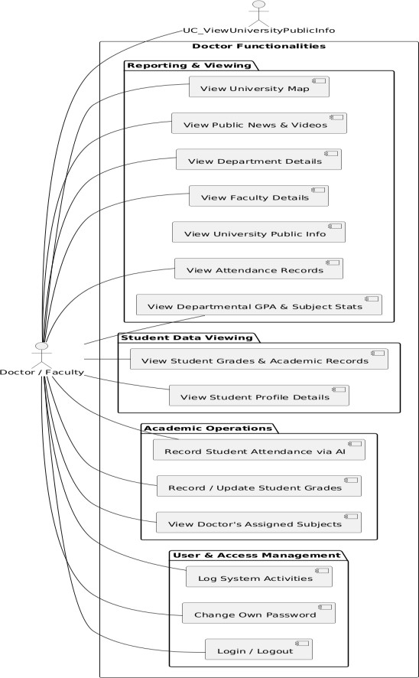
Figure 3.3.1.1: Use Cases for System Doctor
This diagram details the functionalities available to a Doctor or Faculty Member. Their primary interactions revolve around academic operations, including viewing their assigned subjects, managing student grades, participating in AI-based attendance recording, and viewing student data relevant to their courses.

Use Cases for Student
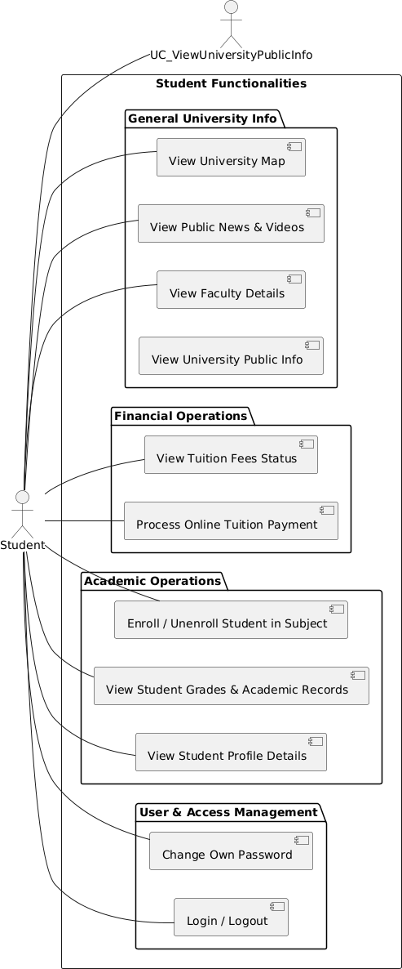
Figure 3.3.1.2: Use Cases for Student

This diagram illustrates the functionalities available to a student. Key interactions include secure login, managing their personal profile, viewing academic records and grades, enrolling in subjects, processing online tuition payments, and accessing general university information and news.

Use Case Descriptions:

Following the Use Case Diagram, this section provides detailed descriptions for selected key use cases. These descriptions elaborate on the functionality of each use case, outlining the actors involved, pre- and post-conditions, and the typical flow of events, along with any significant alternative flows or exceptions. This detailed approach ensures a clear understanding of the system's operational behavior.

Table 3.3.2.1: Key Use Case Descriptions

Use Case Name | Actor(s) | Description
- Login / Logout | System Admin, High-Board, Doctor, Student, Public User | This use case allows users to securely gain access to the system by providing valid credentials (email and password) and to exit the system. Public users can access  login.
Pre-conditions | None
Post-conditions | User is authenticated and redirected to their respective portal, or session is terminated.
Normal Flow | - User navigates to the login page.  - User enters username (email) and password.  - System validates credentials against stored user data.  - If valid, system authenticates user and redirects to their role-specific dashboard (Admin, High-Board, Doctor, Student portal).  - For Logout: User clicks logout button.  - System terminates user session and redirects to login/home page.
Alternative Flows / Exceptions | - Invalid Credentials: System displays an error message.  - Account Locked: System displays an error message indicating the account is locked.
2. Record Student Attendance via AI | Doctor, AI Attendance System | This use case describes the automated process of recording student attendance in real-time using facial recognition technology. It identifies registered students and securely logs their presence for a  specific subject and session.
Pre-conditions | - AI Attendance System is operational and connected to the web application API.  - Student faces are registered and trained in the AI system.  - Doctor is logged in and initiates

 | an attendance session for a specific subject.
Post-conditions | - Student's attendance record is logged in the central database.  - Student is marked as present for the specific subject and session.
Normal Flow | - Doctor initiates attendance session for a subject in the AI Attendance GUI.  - AI Attendance System activates camera and displays live feed.  - System continuously detects faces in the live stream.  - For each detected face, system performs facial recognition against trained student profiles.  - If a student is identified with sufficient confidence and quality, their attendance is recorded internally by the AI system (e.g., to a local CSV buffer).  - System provides visual/audio confirmation of successful attendance for the student.  - Doctor ends the attendance session.  - AI Attendance System sends collected attendance data (Student IDs, Subject ID, Doctor ID, Session ID) to the web application's API.  - Web application API receives data, processes it, and stores it in the central database.  - Web application confirms receipt of data to the AI system.
Alternative Flows / Exceptions | - Face Not Detected: System continues scanning or prompts for better positioning.  - Unrecognized Face: System displays 'Unknown' and does not record attendance.  - Low Image Quality (Blur/Brightness): System warns and skips capturing/processing the image.  - API Communication Failure: System logs error and attempts to retry sending data, or stores locally for later sync.
3. Enroll / Unenroll Student in Subject | Student, High-Board Member | This use case allows a student (or an authorized High-Board member on their behalf) to register for an available subject or remove a  subject from their current enrollment.

Pre-conditions | - Student is logged in (or High-Board member is logged in and authorized).  - Academic records (level, semester) are up-to-date for the student.  - Subject is available for enrollment and student meets prerequisites.
Post-conditions | - Student's enrollment in the subject is updated.  - Student's academic record (credit hours, GPA, level, semester) is recalculated and updated.
Normal Flow (Enrollment) | - Student navigates to the 'Enroll Subjects' page.  - System displays subjects available based on student's academic level and department.  - Student selects desired subject(s) and confirms enrollment.  - System checks if student is already enrolled or if subject capacity is reached.  - If valid, system adds the StudentSubjects record (linking student to subject with initial grade 'F' and degree '0').  - System recalculates and updates the student's academic records (credit hours, GPA, level, semester).  - System confirms successful enrollment.
Normal Flow (Unenrollment) | - Student navigates to 'My Registered Subjects' page.  - Student selects a subject to unenroll from and confirms.  - System checks if this is the last registered subject (to prevent deletion of academic record).  - If valid, system removes the StudentSubjects record.  - System recalculates and updates the student's academic records.  - System confirms successful unenrollment.
Alternative Flows / Exceptions | - Already Enrolled: System displays an error message.  - Subject Capacity Full: System displays an error message.  - Last Subject Deletion Attempt: System displays a warning and prevents deletion.  - Prerequisite Not Met: System prevents enrollment.

4. Record / Update Student Grades | Doctor, High-Board Member | This use case allows an authorized Doctor or High-Board member (e.g., Head of Department, Dean of Faculty) to record or update numerical grades for students in  specific subjects, triggering automatic academic calculations.
Pre-conditions | - Doctor/High-Board member is logged in and authorized for the specific subject/department/faculty.  - Student is enrolled in the subject.
Post-conditions | - Student's grade for the subject is updated.  - Student's academic record (GPA, level, semester, payment status) is recalculated and updated.  - Activity is logged.
Normal Flow | - Doctor/High-Board member navigates to the 'Manage Grades' section for a specific subject or student.  - System displays a list of students enrolled in the subject (or student's subjects).  - Doctor/High-Board member enters/updates the numerical degree for one or more students/subjects.  - System automatically calculates the letter grade (e.g., A+, F) and degree points.  - System updates the StudentSubjects record. 6. System triggers recalculation of student's academic records (GPA, credit hours, level, semester). 7. If academic level changes, system may toggle student's PaymentFees status.  - System logs the grade update activity.  - System confirms successful grade update.
Alternative Flows / Exceptions | - Unauthorized Access: System returns 'Forbid()' for unauthorized users.  - Invalid Degree Input: System  validates input and prompts for correction.

RAG chatbot architecture:

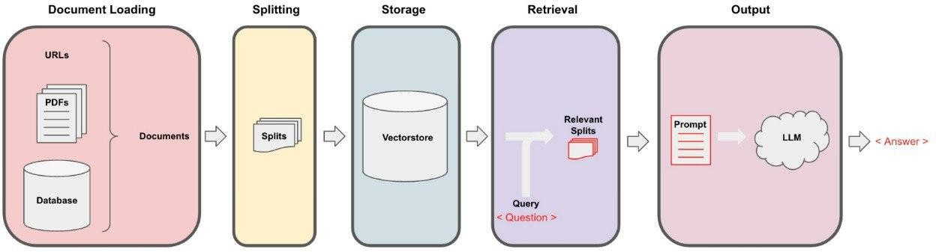

Figure 3.3.3.1: Retrieval-Augmented Generation (RAG) Process Architecture.

Description:
This diagram illustrates the architecture of the Retrieval-Augmented Generation (RAG) process implemented in the AI Chatbot. It depicts the flow from document loading and splitting, through vector storage and retrieval of relevant information, to prompting the Large Language Model (LLM) to generate a final answer based on the query and retrieved context.

Dynamic Behavior

Dynamic behavior describes how the system's objects and components interact with each other over time to achieve specific functionalities. Unlike static diagrams that show the structure, dynamic diagrams illustrate the flow of control and data during system execution. This section focuses on key interaction flows within the Helwan University Smart Management System.

Key Interaction Flow (Sequence Diagram):

Sequence Diagrams are UML interaction diagrams that illustrate how processes operate with one another and in what order. They show the objects participating in the interaction and the sequence of messages exchanged between them. This provides a clear, time-ordered representation of a specific scenario within the system. For our project, we selected the "Student Chatbot Interaction" as a key process to illustrate the dynamic interplay between the web application, the user, and the integrated AI chatbot service.

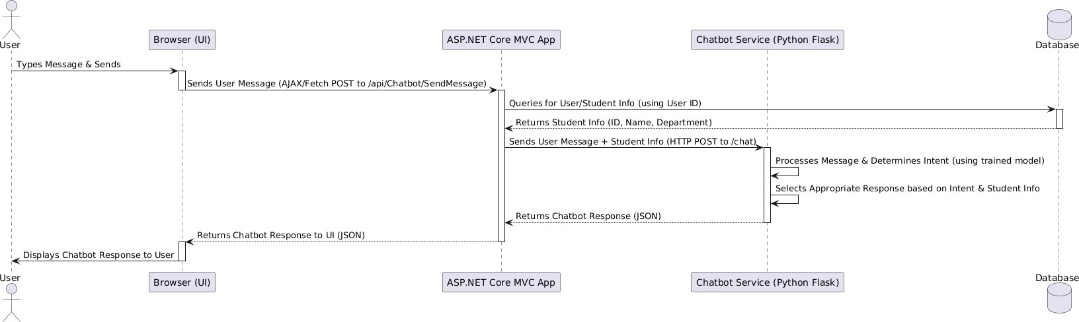
Figure 3.4.1.1: Sequence Diagram for Student Chatbot Interaction

The diagram above illustrates the step-by-step interaction sequence when a student communicates with the AI chatbot through the web application:

- User Initiates Message: The authenticated User types a message into the chat interface within their Browser (UI) and sends it.
- Browser Sends Message to Web App: The Browser (client-side JavaScript) sends an AJAX HTTP POST request to the /api/ChatbotApi/SendMessage endpoint of the ASP.NET Core MVC App.
- Web App Retrieves Student Context: Upon receiving the request, the ASP.NET Core MVC App queries its Database to retrieve detailed information about the authenticated User/Student (e.g., student ID, name, department ID) using the User ID from the authentication claims.
- Database Returns Student Info: The Database responds with the relevant student profile data.
- Web App Forwards to Chatbot Service: The ASP.NET Core MVC App then compiles the original user message along with the retrieved Student Info (student ID, name, department ID) into a payload and sends it as an HTTP POST request to the external Chatbot Service (Python Flask) at its /chat endpoint.
- Chatbot Service Processes Message: The Chatbot Service receives the payload. It then processes the user's message, leveraging its trained models (e.g., NLTK for tokenization, Keras for intent classification, or potentially LangChain/Gemini for RAG) to determine the user's intent. Based on this intent and the provided student context, it selects or generates an appropriate response.
- Chatbot Service Returns Response: The Chatbot Service sends its generated response (which could be plain text or a dynamic link) back to the ASP.NET Core MVC App as a JSON object.
- Web App Returns Response to Browser: The ASP.NET Core MVC App receives the response from the Chatbot Service and directly forwards this JSON response back to the Browser.
- Browser Displays Response: The Browser receives the final response and displays it within the chat interface to the User.

This sequence ensures that the chatbot always has the necessary context about the interacting student, allowing for personalized and accurate responses, even when directing the student to specific information within the university web portal.

State Lifecycle (State Machine Diagram):

A State Machine Diagram is a UML behavioral diagram that illustrates the sequence of states an object goes through during its lifetime in response to events. It is particularly useful for modeling the dynamic behavior of entities that have a well-defined lifecycle with distinct phases and transitions. For the Helwan University Smart Management System, the StudentSubjects entity, which represents a student's enrollment in a specific course and their academic progress within that course, is a prime candidate for a state machine model.

This diagram (Figure 3.4.2.1) depicts the lifecycle of a StudentSubjects record, focusing on how its state changes from initial enrollment to final grading.
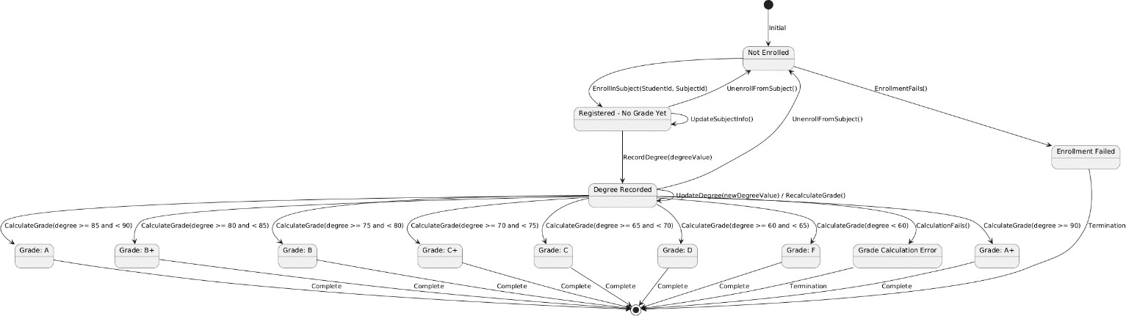
Figure 3.4.2.1: State Machine Diagram for Student Subject Enrollment & Grading

The lifecycle of a StudentSubjects entity proceeds through several key states:

- Initial State: Represents the starting point where a student is not yet associated with a specific subject for enrollment.
- Not Enrolled State: The student is not officially registered for the subject.
  - Transition to Registered - No Grade Yet: Triggered by the EnrollInSubject(StudentId, SubjectId) event, where the student formally registers for the course.
  - Transition to Enrollment Failed: If the enrollment process encounters an issue (e.g., subject capacity full, prerequisites not met), an EnrollmentFails() event leads to this terminal error state.
- Registered - No Grade Yet State: The student is officially enrolled in the subject, but no final grade has been recorded yet. The course is considered "in progress."
  - Transition to Degree Recorded: The primary transition from this state occurs when a numerical Degree is recorded for the student in this subject via the RecordDegree(degreeValue) event.
  - Self-loop (UpdateSubjectInfo()): Updates to subject information (e.g., subject details) or minor administrative changes that don't involve grading keep the entity in this state.
  - Transition to Not Enrolled: An UnenrollFromSubject() event allows the student to drop the subject.
- Degree Recorded State: A numerical degree has been assigned to the student for the subject. This state acts as an intermediary before a specific letter grade is determined.
  - Transitions to Specific Grade States (A+ through F): Based on the CalculateGrade(degreeValue) event, the numerical degree is automatically converted into a letter grade according to the university's grading scale. This leads to one of the final grade states.
  - Self-loop (UpdateDegree() / RecalculateGrade()): If the numerical degree needs to be updated, the entity remains in this state, and the grade is recalculated.
  - Transition to Grade Calculation Error: If the grade calculation process fails for any reason, a CalculationFails() event leads to this terminal error state.
  - Transition to Not Enrolled: An UnenrollFromSubject() event allows the subject to be dropped even after a degree is recorded (e.g., if there's a specific university policy for late drops).
- Specific Grade States (A+, A, B+, B, C+, C, D, F): These represent the final letter grade assigned for the subject. Each is a distinct terminal state for the grading process within the subject.
  - Transition to Complete: Indicates the final successful completion of the subject's grading lifecycle.
- Terminal States: Represent the successful conclusion of the lifecycle (after a grade is assigned) or an abrupt termination due to errors (FailedState, GradeErrorState).

This state machine diagram clearly illustrates the progression of a student's subject enrollment, the critical events that trigger state changes, and the outcomes based on academic performance.

Database Design

The foundation of the Helwan University Smart Management System lies in its robust and well-structured relational database design. This design ensures data integrity, consistency, and efficient retrieval, supporting all core academic, administrative, and AI-driven functionalities.

Entity-Relationship Diagram (ERD):

The Entity-Relationship Diagram (ERD) visually represents the conceptual schema of the database, illustrating the various entities (tables), their attributes, and the relationships connecting them.

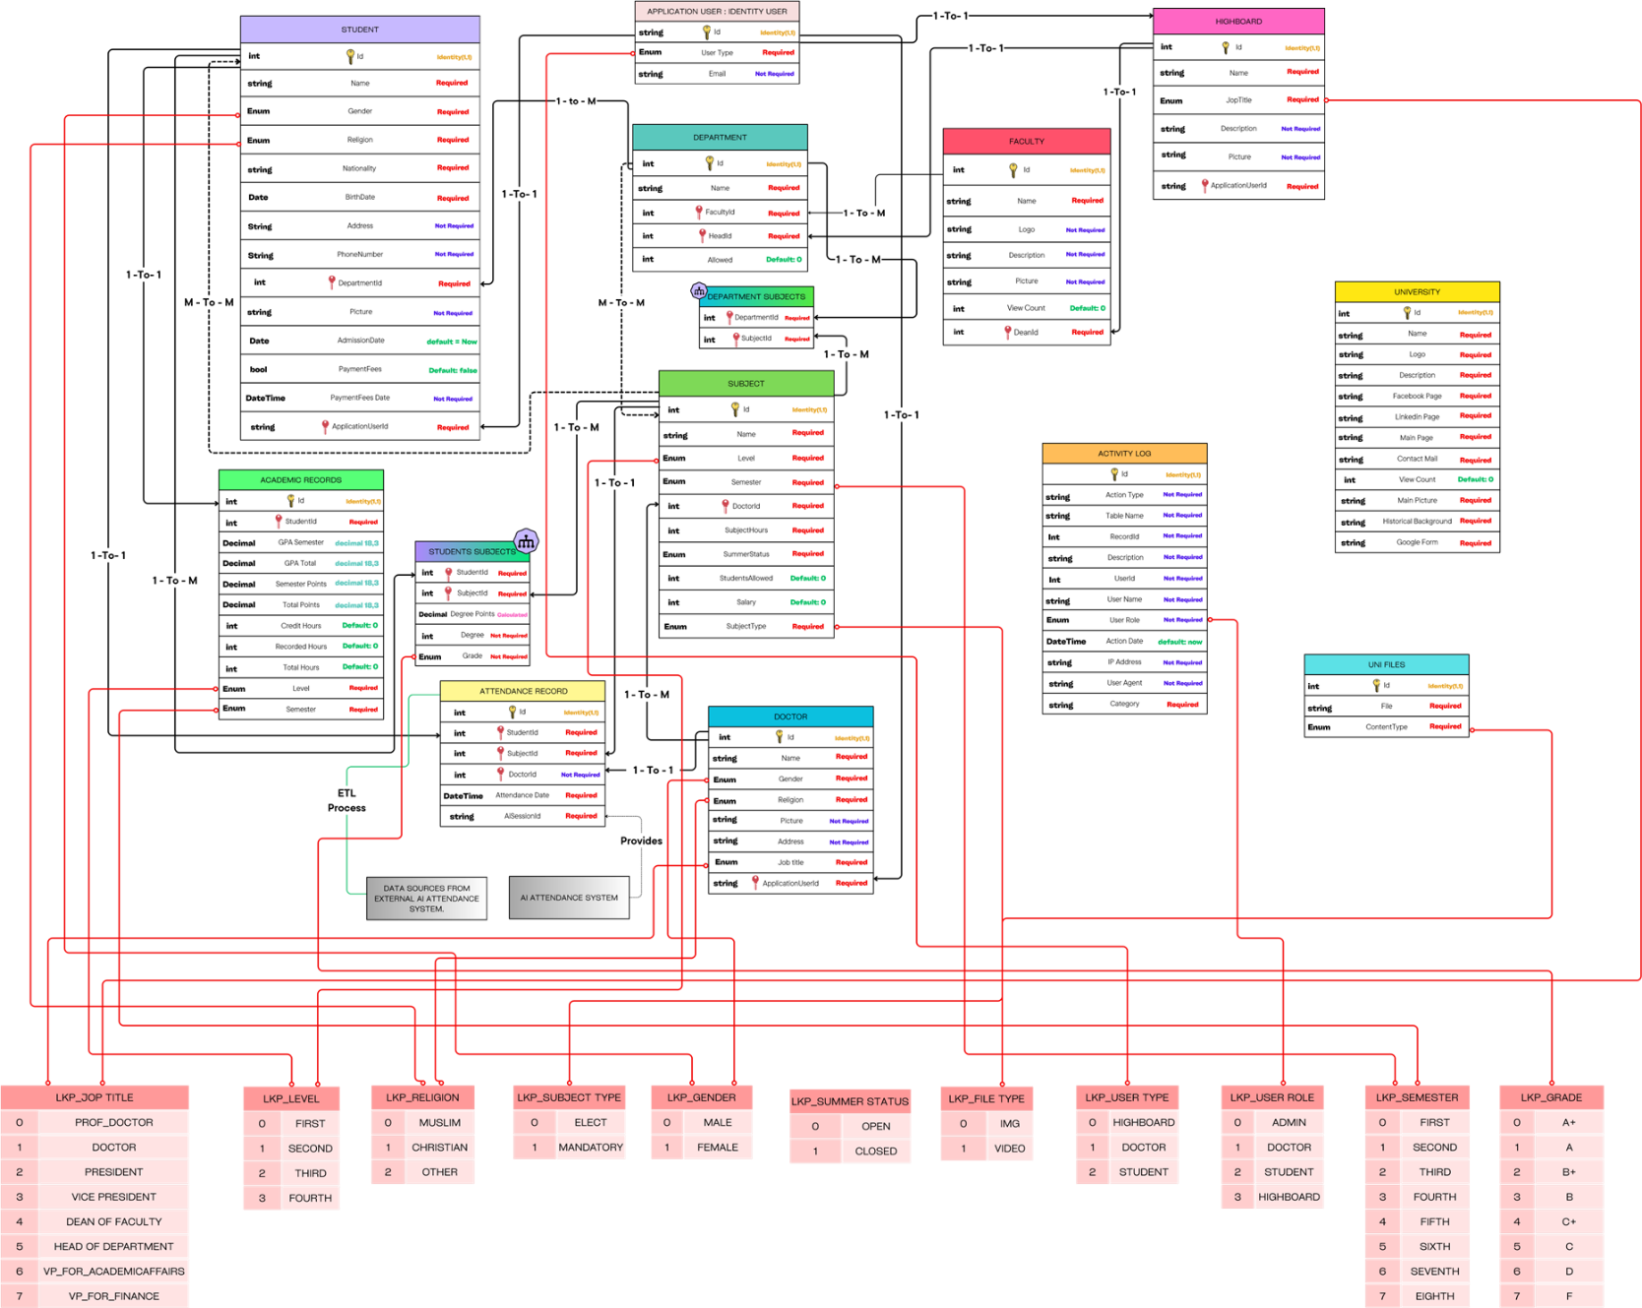
Figure 3.5.1.1: Entity-Relationship Diagram (ERD) of Helwan University

Database Schema Description:

This section describes the main entities (tables) within the database schema, detailing their purpose, key attributes, primary keys, foreign keys, and the nature of their relationships as depicted in the ERD.

ApplicationUser
  - Purpose: Extends ASP.NET Core Identity's default user table, storing authentication credentials and basic user information. It acts as the central account for all system users (Admin, Student, Doctor, High-Board).
  - Primary Key (PK): Id (string, inherited from IdentityUser).
  - Key Attributes: UserType (enum).
  - Foreign Keys (FKs): None (it's the principal entity for other user-specific tables).
  - Relationships: One-to-One with Student, Doctor, and HighBoard (via their ApplicationUserId).

Student
  - Purpose: Stores comprehensive personal and academic data for each student enrolled in the university.
  - Primary Key (PK): Id (int).
  - Key Attributes: Name, Nationality, Gender, Religion, BirthDate, Address, PhoneNumber, Picture, AdmissionDate, PaymentFees, PaymentFeesDate.
  - Foreign Keys (FKs):
  - DepartmentId (FK to Department.Id): Links a student to their academic department.
  - ApplicationUserId (FK to ApplicationUser.Id): Links a student to their login account.
  - Relationships:
  - One-to-Many with Department (a department can have many students).
  - One-to-One with ApplicationUser.
  - One-to-One with AcademicRecords (an academic record belongs to one student).
  - Many-to-Many with Subject (via StudentSubjects).

Doctor
  - Purpose: Stores personal and professional details for faculty members (doctors) within the university.
  - Primary Key (PK): Id (int).
  - Key Attributes: Name, Gender, Religion, Picture, Address, JobTitle.
  - Foreign Keys (FKs): ApplicationUserId (FK to ApplicationUser.Id): Links a doctor to their login account.
  - Relationships:
  - One-to-One with ApplicationUser.
  - One-to-Many with Subject (a doctor can teach many subjects).

HighBoard
  - Purpose: Stores information for high-ranking university officials (e.g., President, Deans, Heads of Departments).
  - Primary Key (PK): Id (int).
  - Key Attributes: Name, Description, JobTitle, Picture.
  - Foreign Keys (FKs): ApplicationUserId (FK to ApplicationUser.Id): Links a high-board member to their login account.
  - Relationships:
  - One-to-One with ApplicationUser.
  - One-to-One with Faculty (a faculty has one dean from HighBoard).
  - One-to-One with Department (a department has one head from HighBoard).

Department
  - Purpose: Represents academic departments within the university.
  - Primary Key (PK): Id (int).
  - Key Attributes: Name, Allowed (e.g., allowed student count).
  - Foreign Keys (FKs):
  - FacultyId (FK to Faculty.Id): Links a department to its parent faculty.
  - HeadId (FK to HighBoard.Id): Links a department to its head (a HighBoard member).
  - Relationships:
  - Many-to-One with Faculty.
  - One-to-Many with Student (a department has many students).
  - Many-to-Many with Subject (via DepartmentSubjects).
  - One-to-One with HighBoard.

Faculty
  - Purpose: Represents academic faculties (colleges) within the university.
  - Primary Key (PK): Id (int).
  - Key Attributes: Name, Logo, Picture, Description, ViewCount.
  - Foreign Keys (FKs): DeanId (FK to HighBoard.Id): Links a faculty to its dean (a HighBoard member).
  - Relationships:
  - One-to-Many with Department (a faculty has many departments).
  - One-to-One with HighBoard.

Subject
  - Purpose: Stores details about academic subjects (courses) offered by the university.
  - Primary Key (PK): Id (int).
  - Key Attributes: Name, Level (enum), Semester (enum), SubjectHours, StudentsAllowed, SummerStatus (enum), SubjectType (enum), Salary.
  - Foreign Keys (FKs): DoctorId (FK to Doctor.Id): Links a subject to its responsible doctor.
  - Relationships:
  - Many-to-One with Doctor.
  - Many-to-Many with Student (via StudentSubjects).
  - Many-to-Many with Department (via DepartmentSubjects).

AttendanceRecord
  - Purpose: Stores individual attendance records generated by the AI attendance system.
  - Primary Key (PK): Id (int).
  - Key Attributes: AttendanceDate, AiSessionId.
  - Foreign Keys (FKs):
  - StudentId (FK to Student.Id): Identifies the student who attended.
  - SubjectId (FK to Subject.Id): Identifies the subject for which attendance was recorded.
  - DoctorId (FK to Doctor.Id, nullable): Identifies the doctor overseeing the session (can be null if AI recorded without specific doctor input).
  - Relationships: Many-to-One with Student, Many-to-One with Subject, Many-to-One with Doctor.

AcademicRecords
  - Purpose: Stores a student's cumulative academic progress, including GPA, credit hours, and current academic level/semester.
  - Primary Key (PK): Id (int).
  - Key Attributes: GPASemester, GPATotal, CreditHours, RecordedHours, TotalHours, SemesterPoints, TotalPoints, Level (enum), Semester (enum).
  - Foreign Keys (FKs): StudentId (FK to Student.Id): Links to the specific student.
  - Relationships: One-to-One with Student.

ActivityLog
  - Purpose: Records significant user actions and system events for auditing, security, and traceability.
  - Primary Key (PK): Id (int).
  - Key Attributes: ActionType, TableName, RecordId, Description, UserId, UserName, UserRole (enum), ActionDate, IPAddress, UserAgent.
  - Foreign Keys (FKs): None (typically independent for auditing).
  - Relationships: Independent entity logging system activities.

DepartmentSubjects
  - Purpose: A join table representing the Many-to-Many relationship between Department and Subject, indicating which subjects are offered by which departments.
  - Primary Key (PK): Composite Key (DepartmentId, SubjectId).
  - Foreign Keys (FKs):
  - DepartmentId (FK to Department.Id).
  - SubjectId (FK to Subject.Id).
  - Relationships: Many-to-Many with Department and Subject.

StudentSubjects
  - Purpose: A join table representing the Many-to-Many relationship between Student and Subject, and crucially, storing the student's Degree and Grade for that specific subject.
  - Primary Key (PK): Composite Key (StudentId, SubjectId).
  - Key Attributes: Degree (nullable), Grade (nullable enum), DegreePoints (computed column).

  - Foreign Keys (FKs):
  - StudentId (FK to Student.Id).
  - SubjectId (FK to Subject.Id).
  - Relationships: Many-to-Many with Student and Subject.

StripeSettings
  - Purpose: Stores configuration settings necessary for integrating with the Stripe payment gateway (e.g., API keys).
  - Primary Key (PK): None (typically stored as a single configuration entry or part of appsettings.json mapped to this model).
  - Key Attributes: SecretKey.
  - Foreign Keys (FKs): None.
  - Relationships: Configuration entity.

UniFile
  - Purpose: Manages general university files, such as images and videos, that are displayed on the website.
  - Primary Key (PK): Id (int).
  - Key Attributes: File (URL or path), ContentType (enum: Image, Video).
  - Foreign Keys (FKs): None (stores file references, not directly linked to other entities as a foreign key).
  - Relationships: Independent entity storing file references.

University
  - Purpose: Stores global information about the university itself (a singleton entity).
  - Primary Key (PK): Id (int).
  - Key Attributes: Name, Description, Logo, MainPicture, FacebookPage, LinkedInPage, MainPage, ContactMail, HistoricalBackground, GoogleForm, ViewCount.
  - Foreign Keys (FKs): None.
  - Relationships: Independent entity representing university-wide static data.

User Interface (UI) Design Principles & Mockups

User Interface (UI) Design Principles & Mockups

The User Interface (UI) of the Helwan University Smart Management System is meticulously designed to provide an intuitive, efficient, and engaging experience for all users. The design philosophy centers on key principles that ensure usability, consistency, and responsiveness across the platform.

UI Design Philosophy

The core principles guiding the UI design are:

- User-Friendliness and Intuitive Navigation: The system's interface prioritizes ease of use, even for first-time users. Navigation paths are logical and straightforward, minimizing the learning curve. Clear labeling, simple layouts, and readily accessible functionalities ensure that users can accomplish their tasks with minimal cognitive effort. The design aims to reduce clicks and simplify complex university processes through well-organized menus and clear calls to action.
- Consistency: A unified design language is applied throughout the entire system, across all user portals (Admin, Doctor, Student, Public). This includes consistent typography, color palettes, iconography, and interactive elements. Consistent placement of common features (e.g., navigation bars, search fields, action buttons) helps users build familiarity and predict system behavior, reducing confusion and improving efficiency.
- Responsiveness and Accessibility: While primarily a web-based platform, the UI is designed to be responsive, ensuring optimal viewing and interaction experiences across various screen sizes, from desktops to tablets. Basic accessibility considerations are integrated to cater to diverse user needs, ensuring that the interface is perceivable, operable, understandable, and robust.
- Aesthetics and Professionalism: The visual design employs a clean, modern, and professional aesthetic that aligns with the university's brand identity. A balanced use of color, whitespace, and visual hierarchy guides the user's attention to critical information and actions. The interface is designed to be visually appealing, contributing to a positive user experience.
- Feedback and Error Handling: The system provides clear and immediate visual feedback to users regarding their actions (e.g., confirmation messages for successful operations, distinct error messages for invalid inputs) and guidance on how to recover from errors.

Key UI Pages (Mockups/Screenshots)

- Login Page
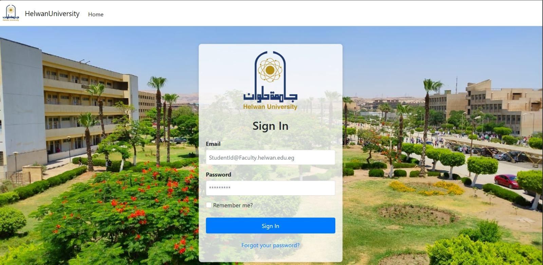
Figure 3.6.2.1: Login Page

Description: Displays the main authentication interface for all users.

Student Dashboard / Profile Page
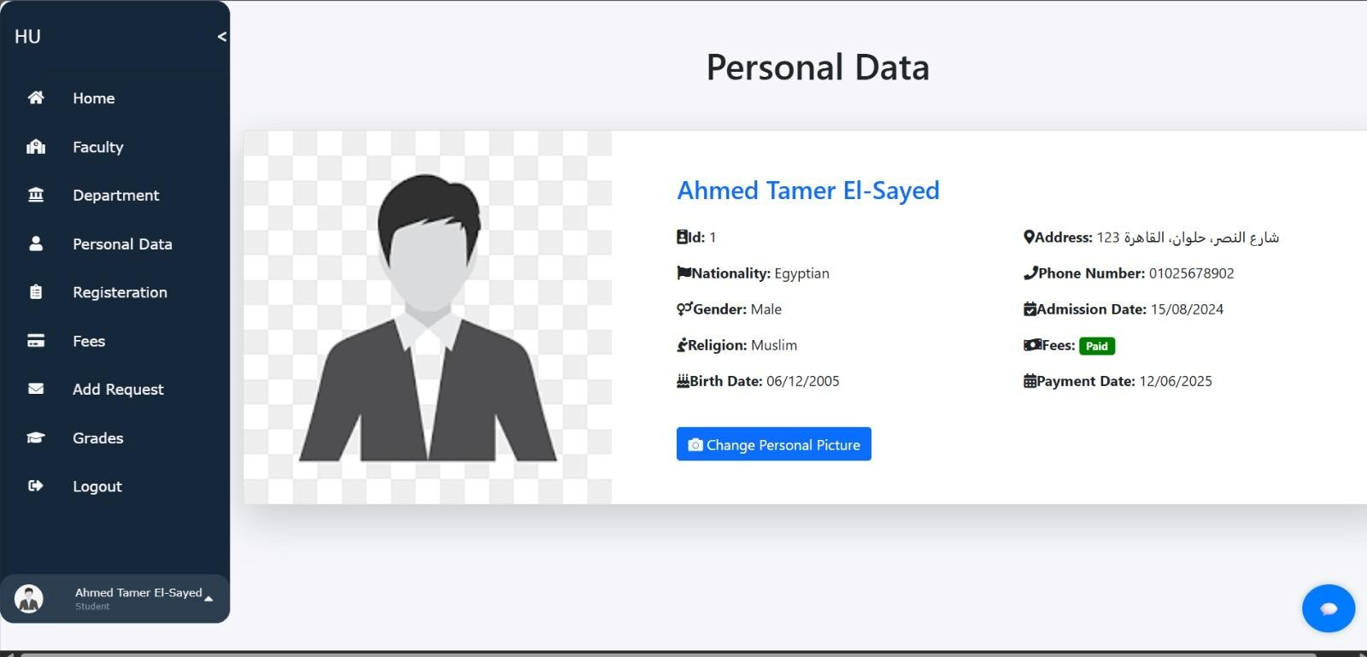
Figure 3.6.2.2: Student Portal Dashboard
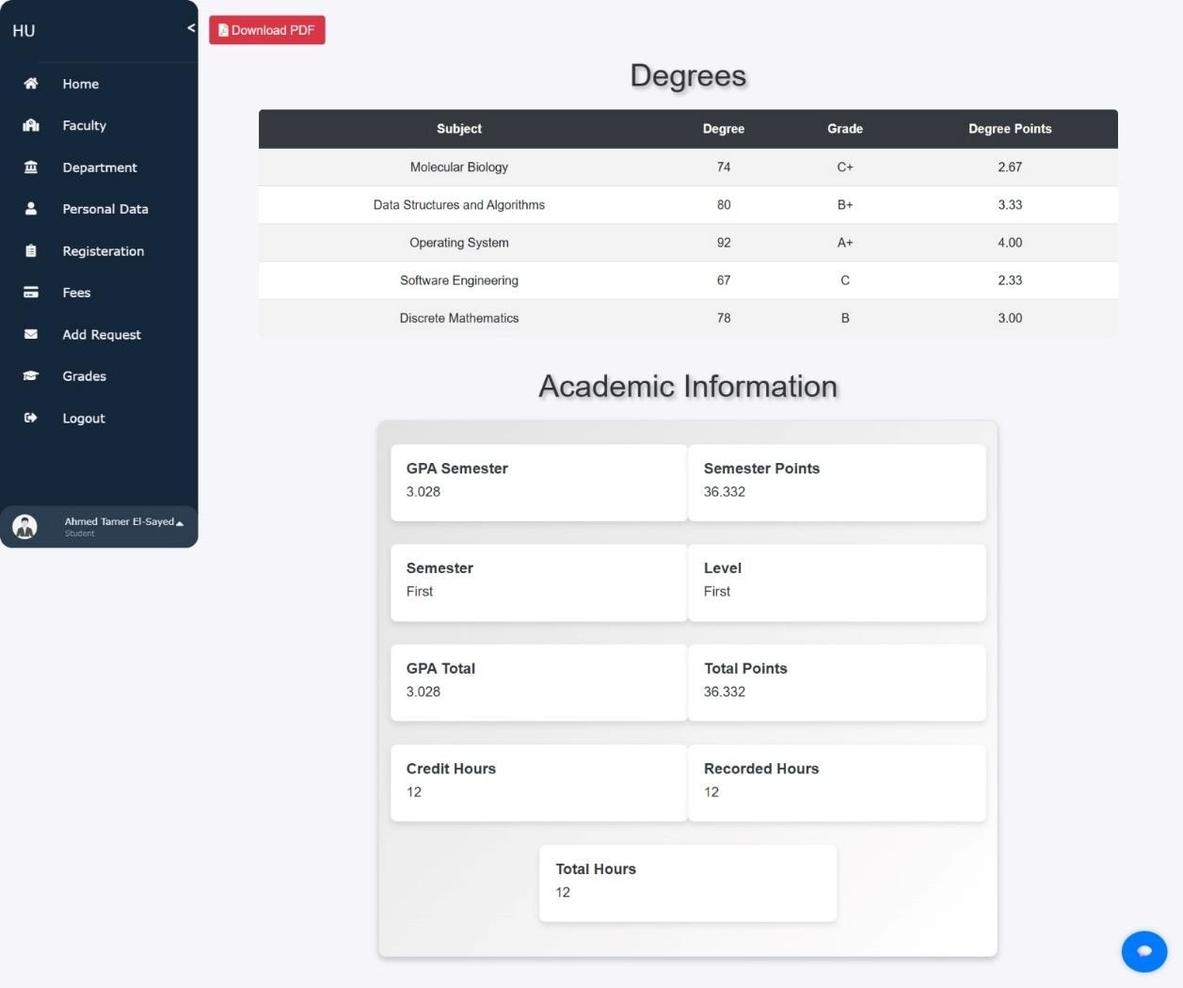
Figure 3.6.2.2: Student Portal Dashboard Academic Overview

Description: Illustrates the student's personalized portal, showcasing academic overview (grades, GPA) and personal details.

Doctor's Subject Management Page
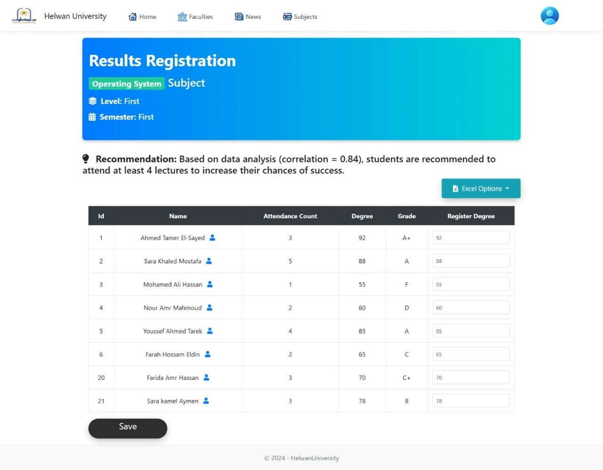
Figure 3.6.2.3: Doctor's Subject Management Page

Description: Shows the interface for doctors to view their assigned subjects and manage (e.g., enter/update) student grades.

Admin Dashboard / Student Management Page
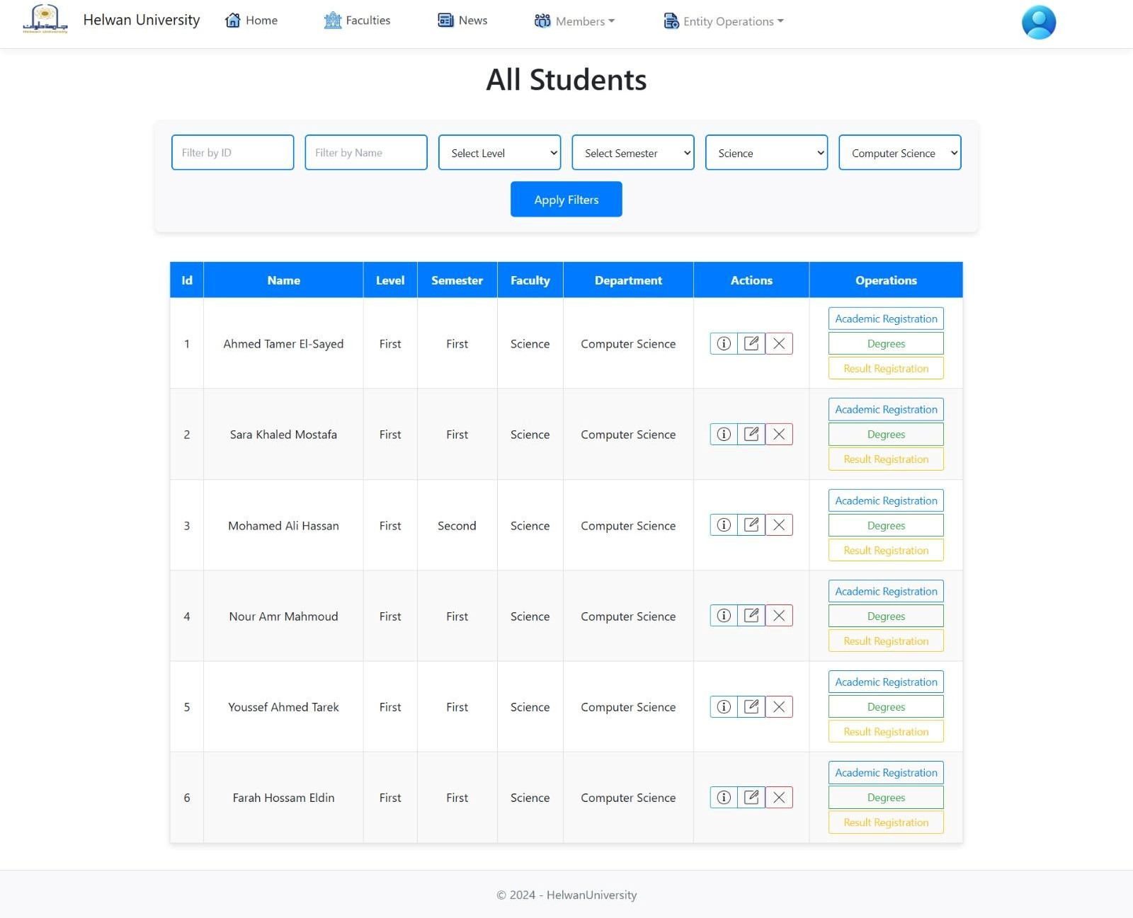
Figure 3.6.2.4: Admin Dashboard / Student Management Page
Description: Presents the administrative interface for managing student profiles, highlighting data tables and action buttons.

AI Attendance System GUI (Capture/Recognition Phase)
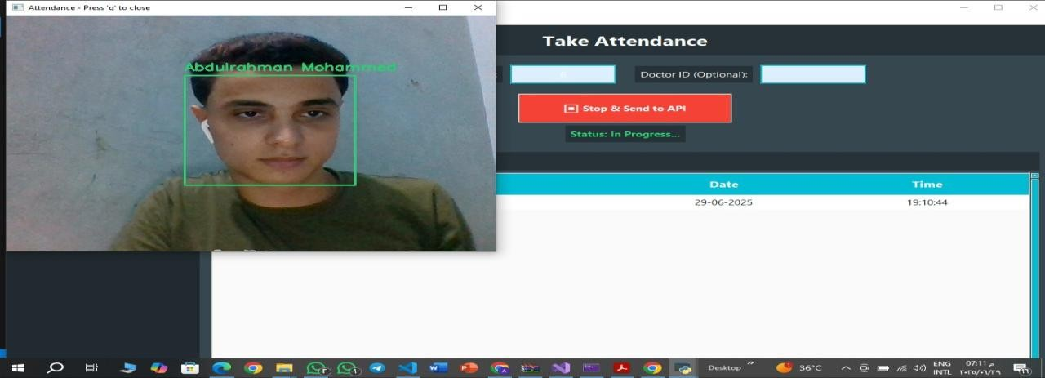
Figure 3.6.2.4: Admin Dashboard / Student Management Page

Description: A screenshot of the Python Tkinter application's camera feed during the attendance recording process, showing face detection/recognition.

Integrated Chatbot Interface
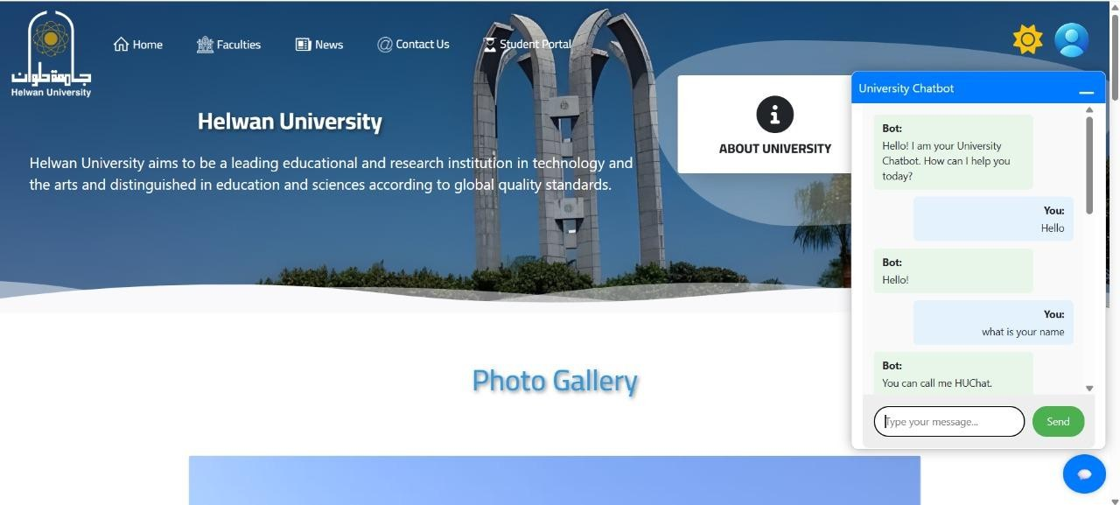

Figure 3.6.2.5: AI Attendance System GUI (Capture/Recognition Phase)
Figure 3.6.2.6.1: Integrated Chatbot Interface
Description: Displays the chatbot pop-up on a typical university page, showing a sample
conversation with HUChat.

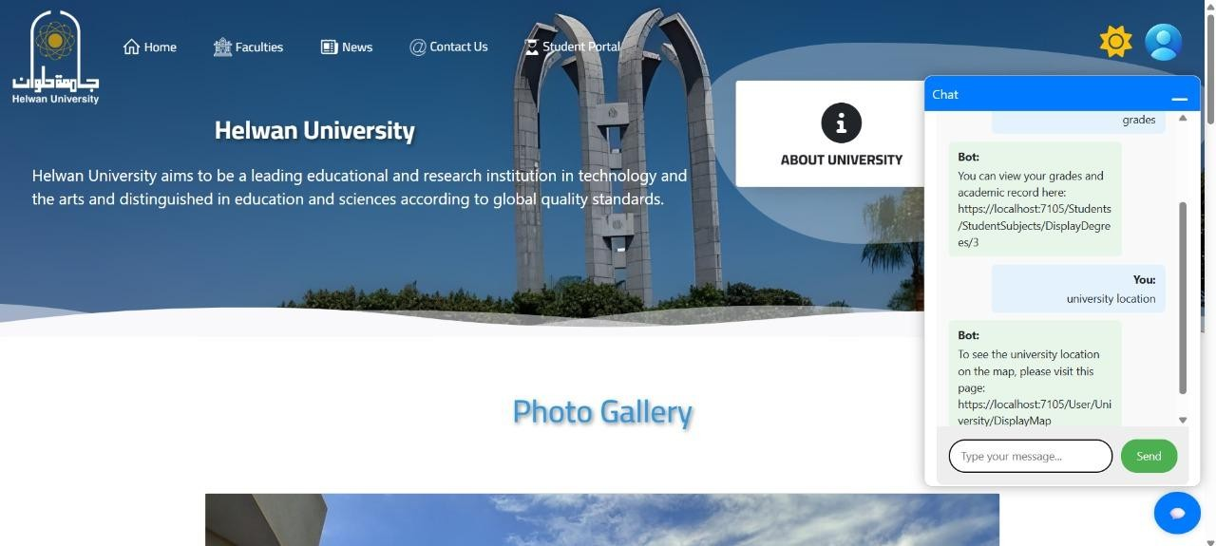
Figure 3.6.2.6.1: Integrated Chatbot Interface

Description: Displays the chatbot pop-up, showing a sample conversation with generated links.
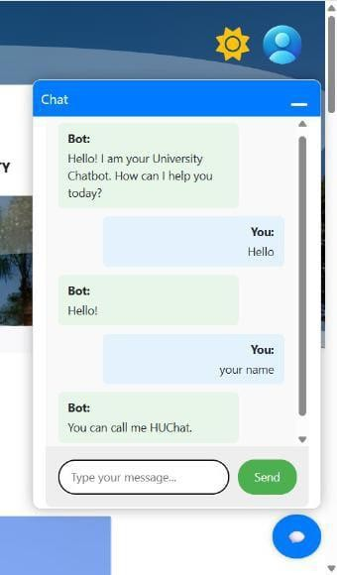
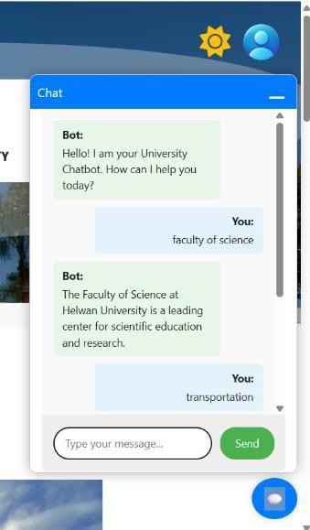
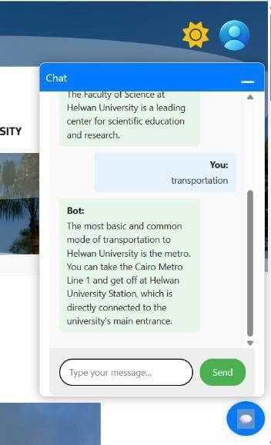

Description: Displays the chatbot pop-up, showing its RAG technology providing relevant.

Academic Reports / Data Visualization Page
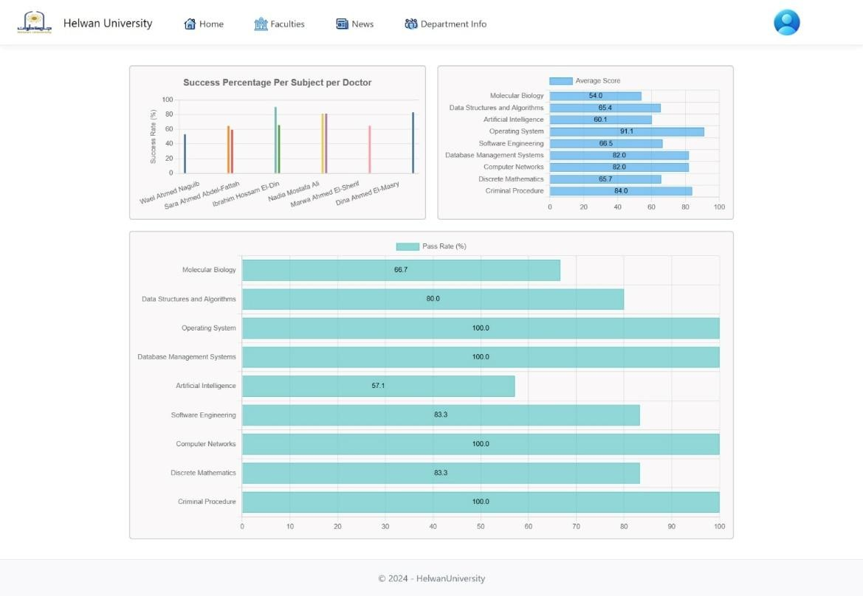
Figure 3.6.2.7: Academic Reports / Data Visualization Page
Description: Highlights an example of an interactive chart or report (e.g., GPA trends by department or subject pass rates).
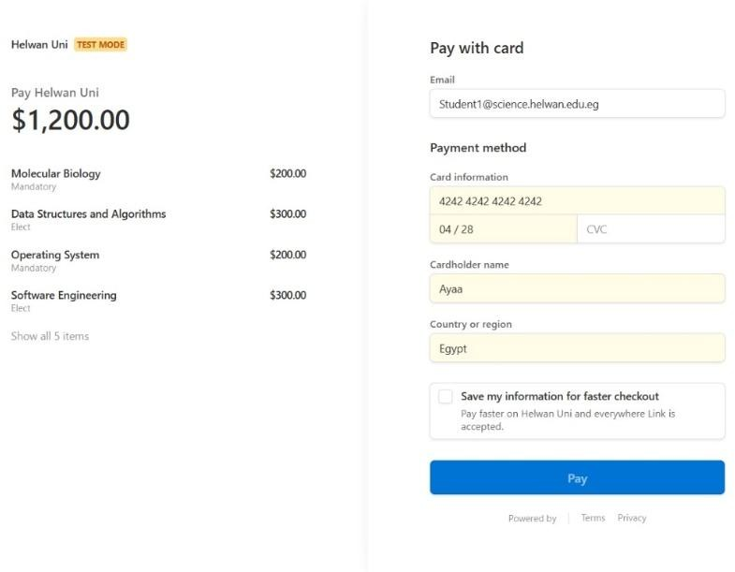
Figure 3.6.2.8: Online Payment Gateway Interface (via Stripe)

Description: A screenshot showing the system's initiation of a payment process, potentially leading to the Stripe checkout page.

Chapter 4: Implementation
The successful implementation of the Helwan University Smart Management System is underpinned by a carefully selected and integrated stack of modern technologies and robust development tools. This chapter details the key technologies and tools utilized across various layers and components of the system, highlighting their specific roles and contributions.

Technologies & Tools Used

The project leverages a diverse set of programming languages, frameworks, libraries, and external services to deliver its comprehensive functionalities.

- C#: As the primary programming language for the backend of the main web application, C# provides a robust, type-safe, and high-performance environment for developing server-side logic, APIs, and data management.
- Python: The language of choice for all Artificial Intelligence (AI) components, Python's rich ecosystem of libraries and frameworks made it ideal for developing the facial recognition attendance system and the intelligent chatbot.
- ASP.NET Core MVC: This open-source, cross-platform framework is the backbone of the main web application. It facilitates the development of scalable web UIs and RESTful APIs, adhering to the Model-View-Controller architectural pattern.
- Flask: A lightweight and flexible Python web framework, Flask is utilized to build the RESTful API service for the AI chatbot. It enables the Python AI logic to communicate seamlessly with the ASP.NET Core backend.
- SQL Server: Serving as the robust relational database management system (RDBMS), SQL Server is used to store and manage all university data, including student profiles, academic records, attendance logs, and administrative information.
- Entity Framework Core (EF Core): As an Object-Relational Mapper (ORM) for .NET, EF Core simplifies data access operations by allowing developers to interact with the SQL Server database using C# objects and LINQ queries, abstracting away complex SQL.
- Keras / TensorFlow: These powerful machine learning frameworks are instrumental in building and deploying the deep learning models used within the AI components. Specifically, TensorFlow and Keras are used for the AI chatbot's intent classification model and potentially in parts of the facial recognition system's underlying models.
- NLTK (Natural Language Toolkit): A leading platform for building Python programs that work with human language, NLTK is employed in the AI chatbot for Natural Language Processing (NLP) tasks such as tokenization and lemmatization, enabling the chatbot to understand user input.
- Cloudinary: An external cloud-based service, Cloudinary provides a comprehensive solution for efficient and scalable storage, management, and delivery of digital assets like student profile pictures, faculty logos, and other multimedia files used across the university platform.
- Stripe: A popular online payment gateway, Stripe is integrated into the system to facilitate secure and convenient processing of student tuition fee payments, streamlining financial transactions.

- HTML, CSS, JavaScript: These foundational web technologies are used for developing the frontend user interface of the ASP.NET Core web application, ensuring a responsive, interactive, and visually appealing experience for users.
- Visual Studio: The primary Integrated Development Environment (IDE) used for developing the ASP.NET Core MVC application, providing tools for coding, debugging, and project management.
- VS Code (Visual Studio Code): A versatile code editor used for developing and managing the Python-based AI components (AI Attendance System, Flask Chatbot service) and for general code editing tasks.
- Jupyter Notebook: Employed during the development and experimentation phase of the AI models, Jupyter Notebook provides an interactive environment for data analysis, model training, and testing Python code.

Software Development Details

This section elaborates on the practical aspects of software development within the Helwan University Smart Management System. It details the structure and responsibilities of key software modules and components, providing insight into how the system's functionalities are implemented.

Module/Component Implementation Overview:

The backend of the Helwan University Smart Management System is built using a modular and layered approach, primarily leveraging the Model-View-Controller (MVC) architectural pattern within ASP.NET Core. The responsibilities of Controllers, Repositories, and Services are clearly defined to promote separation of concerns, maintainability, and scalability.

Controllers

Responsibility: Controllers serve as the entry points for HTTP requests from the client (web browser or external APIs). Their primary roles include:

Request Handling: Receiving and routing incoming requests to appropriate action methods.

Orchestration: Coordinating calls to business logic (Services) and data access layers (Repositories) to process requests.

Response Generation: Preparing data to be displayed in Views or returned as API responses (e.g., JSON).

Authentication & Authorization: Enforcing access control based on user roles ([Authorize(Roles = "...")]) and implementing more granular permission checks within action methods (e.g., verifying user ownership of a profile or departmental authority for High-Board members).

Structure: Controllers are logically organized into distinct "Areas" (e.g., Admin, Doctors, Students, User). Each Area encapsulates controllers and views relevant to a specific user role or functional domain, enhancing modularity and manageability.

Interaction: Controllers communicate directly with Services to apply business rules and with Repositories to perform data operations. They render Views or return IActionResult types (e.g., View(), Json(), Ok(), NotFound(), Forbid()).

Repositories

Responsibility: Repositories act as an abstraction layer between the business logic and the data persistence layer. Their main responsibilities are:

Data Access Abstraction: Providing a clean, technology-agnostic interface for data operations, abstracting away the underlying database specifics (SQL Server, Entity Framework Core).

CRUD Operations: Implementing standard Create, Read, Update, and Delete functionalities for specific entities (e.g., StudentRepository for Student entities).

Specific Query Methods: Offering tailored methods for retrieving data based on complex criteria (e.g., ISubjectRepository.SubjectsByDoctor(id) to get subjects assigned to a specific doctor, IAttendanceRecordRepository.GetAttendanceForCourseOnDateAsync(...) for attendance records).

Structure: Each entity or logical data collection typically has a pair of components:

Interface (e.g., IStudentRepository, IAttendanceRecordRepository): Defines the contract for data operations, ensuring loose coupling.

Concrete Implementation (e.g., StudentRepository, AttendanceRecordRepository): Provides the actual implementation of the interface methods, using ApplicationDbContext (Entity Framework Core) to interact with the database.

Interaction: Repositories are injected into Controllers and Services using Dependency Injection. They interact directly with ApplicationDbContext to execute database queries and persist changes. Some repositories (AcademicRecordsRepository, DepartmentRepository) collaborate by injecting and utilizing methods from other repositories to fulfill complex data requirements.

Services

Responsibility: Services encapsulate reusable business logic, cross-cutting concerns, and complex operations that might involve coordination between multiple repositories or external integrations. They ensure that business rules are applied consistently across the application.

Components: Business Logic Services (e.g., IActivityLogger, ActivityLogger): These services contain application-specific business rules that extend beyond simple CRUD operations. For instance, ActivityLogger is responsible for recording user actions and system events for auditing and security purposes.

External Integration Services (e.g., ICloudinaryService, CloudinaryService): These services manage interactions with third-party APIs and platforms, abstracting the complexities of external communication. CloudinaryService handles file uploads to cloud storage, while implicit services manage Stripe payment gateway interactions.

Structure: Similar to repositories, services are defined by interfaces (e.g., IActivityLogger, ICloudinaryService) and implemented by concrete classes.

Interaction: Services are typically injected into Controllers or other Services/Repositories. They execute business logic, call methods on repositories to access data, and interact with external APIs as needed.

Key Algorithms / Business Logic:

This section elaborates on the core algorithms and business logic functionalities that drive the Helwan University Smart Management System. It provides a detailed understanding of how key operations are processed and managed within the application, including complex academic calculations and intelligent AI-driven functionalities.

GPA and Academic Progression Calculation
The system features a robust, automated module for managing student academic progression, triggered primarily by the entry or modification of subject grades. This ensures real-time accuracy and consistency in student records.

        - Grade Determination: Upon a doctor or administrator entering a numerical degree for a student in a specific subject, the system immediately converts it into a corresponding letter grade (e.g., A+, B, C, D, F) based on predefined university grading scales. This logic is encapsulated within the CalculateGrade function of the IStudentSubjectsRepository implementation.
        - GPA Calculation (Semester & Total): The system dynamically computes two types of Grade Point Average:
          - Semester GPA: Calculated for each completed semester based on the SemesterPoints and RecordedHours accumulated by the student for that specific period, using the CalculateGpaSemester function.
          - Total GPA: A cumulative GPA is determined by aggregating all TotalPoints and TotalHours across the student's entire academic history, utilizing the CalculateGPATotal function.

Credit Hours Accumulation & Academic Level/Semester Determination:
          - The system meticulously tracks the total CreditHours successfully completed by a student (subjects passed with a grade of D or higher). This is managed by the CalculateCreditHours function.
          - Based on these accumulated CreditHours, the student's current Academic Level (e.g., First Year, Second Year) and Semester are automatically determined. This progression logic is defined within the CalculateLevel and CalculateSemester functions.
        - Dynamic Subject Availability & Payment Fees Status: The updated academic level and completed credit hours directly influence the subjects a student is eligible to register for in future semesters. Additionally, in a unique business rule, the system automatically toggles the student's PaymentFees status (from paid to unpaid, or vice-versa) if their academic level changes, serving as an automated trigger for financial administration.
        - Real-time Updates: All these calculations are integrated into an UpdateAcademicRecords helper method, which is invoked automatically whenever a grade is added or modified, ensuring that academic records are always current

.

AI Chatbot Intent Classification & Response Generation

The AI chatbot employs a sophisticated hybrid approach to understand student queries and generate appropriate responses, combining rule-based, knowledge retrieval, and machine learning classification techniques.

Hybrid Response Logic:
          - Priority 1: Static Rules for Direct Links: The chatbot first attempts to match the user's message against predefined keywords in static_rules.json. If a match is found (e.g., for "grades", "profile", "department info"), it generates a direct link to the relevant personalized page within the university web portal, formatted with the student's ID or Department ID. This ensures quick and accurate redirection for common queries.
          - Priority 2: Valid Message Check: If no static rule matches, the system checks if the message is a valid, clear query (e.g., not too short, contains alphabetic characters) to avoid processing gibberish or spam.
          - Priority 3: RAG (Retrieval-Augmented Generation) with Google Gemini Flash: For general university questions not covered by static rules, the system queries a knowledge base (CSV data loaded into ChromaDB) using LangChain and Google Gemini Flash as the Large Language Model (LLM). This allows the chatbot to generate natural, informative responses from its trained knowledge.
          - Priority 4: Fallback to Intent-based (Keras/NLTK Model): If the RAG process fails (e.g., due to API quota exhaustion or other ResourceExhausted exceptions), the system falls back to a locally trained Keras/NLTK model. This model classifies the user's intent from helwan_data.json and selects a random predefined response for that intent. This ensures a fallback mechanism is always available.

Text Preprocessing and Intent Classification (Keras/NLTK):
          - clean_up_sentence function: Takes the user's raw message, tokenizes it into words (nltk.word_tokenize), converts words to lowercase, and applies lemmatization (WordNetLemmatizer) to reduce words to their base form. This prepares the text for feature extraction. A fallback mechanism is implemented to use simple string splitting if NLTK data is unavailable.
          - bag_of_words function: Converts the cleaned sentence into a numerical vector (Bag-of-Words representation). This vector indicates the presence or absence of words from a predefined vocabulary (words.pkl).
          - predict_class function: Takes the Bag-of-Words vector and feeds it to the trained Keras neural network model (chatbot_model.h5). The model outputs probabilities for each predefined intent. An ERROR_THRESHOLD is applied to select intents with sufficient confidence.
          - get_response_from_json function: Based on the highest confidence intent predicted, this function retrieves a random response from the intents.json file.

AI Attendance Processing Logic

The AI Attendance System automates student attendance recording through a multi-stage process involving image capture, facial recognition model training, and real-time identification.

Image Capture & Quality Control (TakeImages function):
          - The system uses the device's webcam (cv2.VideoCapture) to capture student facial images for training.
          - It employs face_recognition.face_locations to detect faces within the frames.
          - Image Quality Checks: Before saving, each captured face image undergoes quality control based on:
            - Blurriness: Measured using calculate_laplacian_variance (Laplacian variance) against a BLUR_THRESHOLD.
            - Brightness: Measured using calculate_brightness (mean pixel intensity) against BRIGHTNESS_LOW_THRESHOLD and BRIGHTNESS_HIGH_THRESHOLD.
          - Only high-quality, clear images are saved to the TrainingImage directory, tagged with student name, serial, and ID, ensuring optimal training data.

Face Encoding & Model Training (TrainImages function):
          - Encoding Extraction: The get_encodings_and_labels function processes all training images. It uses face_recognition.face_encodings to extract unique 128-dimensional facial embeddings (numerical representations) for each detected face.
          - Performance Optimization (Multiprocessing): This process is significantly accelerated by utilizing multiprocessing.Pool to process images in parallel across multiple CPU cores.
          - Intelligent Caching: Processed encodings and labels are stored in ENCODINGS_CACHE_FILE. The system intelligently identifies and processes only new or modified images, rebuilding the entire cache only if files are deleted, saving substantial training time.
          - Model Training: Once encodings are extracted, a LabelEncoder maps student serial numbers to numerical labels, and a Support Vector Machine (SVC) model from scikit-learn is trained on these encodings and labels. This SVC model serves as the core face recognition classifier.
          - The trained SVC model and LabelEncoder are serialized and saved to svc_model.pkl and labels.pkl respectively for later use.

Real-time Attendance Tracking & Recognition (TrackImagesAuto function):
          - The system loads the trained SVC model and LabelEncoder at the start of an attendance session.
          - It continuously captures frames from the webcam.
          - Face Detection & Tracking: face_recognition.face_locations detects faces, and cv2.legacy.TrackerKCF_create() is used to track identified faces across frames, improving stability and performance.

          - Recognition & Confidence: For each tracked face, svc_model.predict_proba estimates the probability of belonging to known students. A CONFIDENCE_THRESHOLD is applied, and identified students are logged.
          - Stable Recognition Buffer: To prevent flickering or incorrect rapid recognition, a buffer (recognition_buffers) stores recent recognition results for a defined number of RECOGNITION_CONFIRMATION_FRAMES. Attendance is only recorded when recognition is stable over these frames.
          - Integration with Web Application API: Upon confirmed recognition, the system formats the attendance data (Student ID, Subject ID, Doctor ID, Session ID) and sends it as an HTTP POST request to the ASP.NET Core MVC application's AttendanceApi controller, ensuring real-time database updates.
        - Liveness Detection (Note on Scope): It is important to note that, as per the project's scope for performance optimization, advanced liveness detection (anti-spoofing) is disabled in the current implementation of TrackImagesAuto and is marked as a future enhancement.
        - Data Management: Attendance records are also maintained in local CSV files for daily logs before being sent to the central database.

Challenges Encountered During Implementation & Their Solutions:

The development of a complex, integrated system like the Helwan University Smart Management System invariably presents various technical challenges. Overcoming these hurdles was a critical part of the project's learning process and contributed significantly to the robustness and reliability of the final solution. This section details the specific technical challenges encountered during implementation and the strategies employed to address them.

      - Performance Bottlenecks: The N+1 Query Problem

        - Problem: A recurring performance issue encountered across various repository methods was the "N+1 Query Problem." This manifests when an application retrieves a list of parent entities and then, in a subsequent loop, executes a separate database query for each parent to retrieve its related child entities. This leads to a high number of inefficient database calls, severely impacting application responsiveness, especially with larger datasets.
        - Solution: To mitigate the N+1 query problem, several optimization techniques were applied:
          - Eager Loading: Utilizing Entity Framework Core's Include() and ThenInclude() methods to explicitly load related entities in a single query.
          - Projection: Employing LINQ's Select() to project query results directly into lightweight DTOs or anonymous types, fetching only the necessary columns rather than entire entity objects.
          - Batching & Pre-fetching: For scenarios involving lists, related data was often pre-fetched in a single query (e.g., loading all relevant related entities into memory first) before iterating or performing in-memory lookups, thus avoiding individual database calls within loops.
          - Asynchronous Operations: Converting I/O-bound repository methods to async with await (e.g., FirstOrDefaultAsync(), ToListAsync()) improved application responsiveness and scalability by freeing up server threads while waiting for database operations to complete.

DataBase Schema Integrity : OnDeleteBehavior Conflicts

        - Problem: During the definition of entity relationships in ApplicationDbContext (using Entity Framework Core's Fluent API), conflicts arose due to DeleteBehavior.Cascade being set on multiple foreign keys, leading to the "Multiple Cascade Paths" error during database migrations. This error occurs when deleting a parent record could trigger cascading deletions through more than one path, creating ambiguity for the database. Furthermore, some default Cascade behaviors (e.g., deleting a Department leading to deletion of all associated Students) posed significant risks of unintended data loss.

        - Solution: To resolve these conflicts and ensure data integrity, the OnDeleteBehavior for problematic relationships was carefully reconfigured in ApplicationDbContext.OnModelCreating. For critical relationships, DeleteBehavior.NoAction or DeleteBehavior.Restrict was explicitly set. This prevents automatic cascading deletions at the database level. Instead, deletion logic for dependent entities (e.g., DepartmentSubjects when a Department is deleted) was handled manually within the respective repository methods (e.g., DepartmentSubjectsRepository.DeleteRelations), often utilizing RemoveRange for efficiency, allowing for more controlled and audited data removal.

AI API Integration (ASP.NET Core & Python Services)

        - Problem: Integrating the ASP.NET Core MVC application (C#) with the Python-based AI services (Attendance System and Chatbot) presented several challenges:
          - HTTPS Certificate Verification: During local development, using https://localhost from Python requests library often led to SSLError due to self-signed certificates.
          - JSON Serialization/Deserialization: Ensuring consistent data formats (JSON) between C# (Newtonsoft.Json) and Python (Flask request.json, json module) was crucial. Mismatches in key casing (camelCase vs. snake_case) or unexpected null values caused parsing errors.
          - Network Errors: Handling HttpRequestException for connection failures or timeouts between services required robust try-catch blocks.
          - Contextual Payload: Passing necessary user-specific context (e.g., student_id, student_name, student_department_id) from the authenticated C# backend to the Python AI services required careful payload design.

Solution:
          - For development, verify=False was temporarily added to Python requests calls when connecting to https://localhost.
          - Newtonsoft.Json was configured in ASP.NET Core to handle ReferenceLoopHandling.Ignore for complex object graphs during serialization, and careful attention was paid to naming conventions for JSON properties.
          - Comprehensive try-catch blocks were implemented around API calls in both C# Controllers and Python services to manage network failures, timeouts, and unexpected responses gracefully.
          - Structured ViewModels (e.g., ChatMessageViewModel) were designed in C# to ensure predictable data payloads for Python, including all necessary student context extracted from ClaimTypes.NameIdentifier and IStudentRepository.

Python Environment & Library Compatibility Issues

        - Problem: This proved to be one of the most persistent and challenging areas. Issues included:
          - ModuleNotFoundError: Initially for core libraries like opencv-python, Pillow, pandas, requests, contractions, matplotlib.
          - numpy.dtype size changed (ValueError): A severe binary incompatibility between NumPy and SciPy (or other dependent libraries like dlib indirectly) due to conflicting versions.
          - LookupError: Resource punkt not found: Persistent NLTK data download and loading issues, preventing text tokenization.
          - ERROR: Failed building wheel for dlib: The notoriously difficult process of compiling dlib from source on Windows, even after installing Microsoft Visual C++ Build Tools.
          - CondaSSLError: A critical OpenSSL issue within the Anaconda environment preventing conda from securely downloading any package, rendering conda install ineffective.

        - Solution: An iterative and often drastic troubleshooting process was required:
          - Explicit pip install: Systematically installing each missing module using pip install <module-name>.
          - Version Specificity: For compatibility issues, specific versions of libraries (e.g., numpy<1.25.0 to match older scipy) were attempted, or the latest compatible versions were sought.
          - Clean Reinstallation: Frequent pip uninstall -y followed by pip install (or conda uninstall and conda install) was necessary.
          - NLTK Data Path & Download: Explicitly setting nltk.data.path to a custom, accessible directory and running !python -m nltk.downloader -d <path> within Jupyter cells ensured data downloaded to and loaded from the correct location. A fallback tokenization method was also implemented in clean_up_sentence to allow the system to function even if NLTK's punkt tokenizer was unavailable.
          - dlib Build Failure: As a last resort for dlib, the most reliable solution was to abandon building from source and instead download a pre-compiled .whl file specifically for Python 3.12.2 (e.g., from Christoph Gohlke's unofficial repository, or alternative GitHub repositories for pre-built wheels) and install it manually using pip install <path-to-whl-file>.
          - CondaSSLError Resolution: For persistent CondaSSLError, the ultimate solution involved a complete reinstallation of Anaconda, followed by careful re-creation of the environment and package installations. This addressed underlying SSL certificate and OpenSSL library conflicts within the Conda base environment.

Complex Role-Based Authorization Enforcement

        - Problem: Ensuring that users could only access and manipulate data relevant to their specific role and hierarchical position (e.g., a student only sees their own profile, a doctor only manages grades for their assigned subjects, a Department Head only views/manages their department's data, a Dean only for their faculty's data) added significant complexity to authorization beyond basic role checks.
        - Solution: This was achieved through a multi-layered approach:
          - [Authorize(Roles = "RoleName")]: Basic access control applied at the Controller or Action Method level to filter users by their primary role.
          - User Entity Retrieval: Within Action Methods, the authenticated UserId (ClaimTypes.NameIdentifier) was used to retrieve the corresponding Student, Doctor, or HighBoard entity (doctorRepository.GetEntityByUserIdAsync, studentRepository.GetByUserId).
          - Granular Data Verification: Explicit conditional logic (if (entity is Doctor doctor && doctor.Id != requestedId)) or if (highBoard.JobTitle == JobTitle.HeadOfDepartment && student.DepartmentId != highBoard.Department.Id) was implemented to verify that the requested entity's ID or its departmental/faculty affiliation matched the authenticated user's specific access rights.
          - Forbid() Action: If authorization checks failed, the Controller returned Forbid() to explicitly deny access, indicating that the user is authenticated but not authorized for that specific resource.
          - Activity Logging: Unauthorized access attempts and critical permission-related actions were logged for auditing and security monitoring.

AI Attendance Liveness Detection Trade-off

        - Problem: To achieve near real-time performance for the AI attendance system on potentially less powerful hardware (e.g., Raspberry Pi if deployed there), the implementation of sophisticated liveness detection (anti-spoofing) was temporarily disabled. This was a trade-off between speed and advanced security against spoofing attacks (e.g., presenting a photo to the camera).
        - Solution: While disabled for current performance needs, this limitation is documented as a known area for future work, with plans to explore and integrate more advanced liveness detection techniques to enhance security against spoofing attacks.

Chapter 5: Testing & Evaluation

Testing Methodology

Software testing is an indispensable phase in the software development lifecycle, ensuring that the system functions correctly, meets all specified requirements, and delivers a high-quality user experience. For the Helwan University Smart Management System, a multi-faceted testing methodology was adopted, encompassing various levels of testing to validate different aspects of the application.

Unit Testing

Description: Unit testing involves testing individual components or "units" of the source code in isolation. The goal is to verify that each unit of the software performs as designed and meets its specifications.

Application in Project: While comprehensive unit testing was not the primary focus given project constraints, critical algorithms and business logic functions within the Services and Repository Implementations (e.g., GPA calculation functions in StudentSubjectsRepository.cs, grade determination logic, specific data retrieval methods) were informally tested to ensure their isolated correctness.

Integration Testing

Description: Integration testing focuses on verifying the interfaces and interactions between different modules or components of the system. It aims to expose defects in the interfaces and communication paths between integrated units.

Application in Project: This was a crucial testing phase for our system due to its integrated nature. Key integration points tested included:

Controllers with Repositories: Verifying that Controllers correctly invoke Repository methods and handle returned data.

Repositories with ApplicationDbContext: Ensuring seamless data persistence and retrieval through Entity Framework Core.

ASP.NET Core Backend with Python AI Services: Thoroughly testing the RESTful API communication for both the AI attendance system and the chatbot. This included verifying payload structures, response handling, and error propagation across the C# and Python boundary.

Web Application with External Services: Testing the successful integration and functionality of Cloudinary for file uploads and Stripe for online payment processing.

System Testing

Description: System testing evaluates the complete and integrated software system against its specified requirements. This stage aims to verify that all components work together cohesively and that the system as a whole meets both functional and non-functional requirements.

Application in Project: After individual components and integrations were validated, the entire Helwan University Smart Management System was tested end-to-end. This included:

Functional Verification: Ensuring all major functionalities (e.g., student registration, grade management, attendance recording, chatbot interaction, report generation, role-based access) worked as intended across all user portals.

Non-Functional Verification: Preliminary assessments of performance (e.g., API response times, page load speeds), security (e.g., unauthorized access attempts), and usability were conducted.

Environment Validation: Confirming the system's stability and functionality within a simulated deployment environment.

Test Cases & Results

This section provides a selection of representative test cases conducted during the testing phase of the Helwan University Smart Management System. These test scenarios demonstrate the successful validation of key functionalities across different user roles and system components, ensuring the system operates as designed and meets its specified requirements.

Table 5.2.1: Selected Test Cases and Results

Test Case  ID | Test Scenario  Description | Actor(s) | Pre-conditions | Input Data / Actions | Expected Outcome | Actual Outcome | Status
TC-001 | Successful Student Login | Student | Student account exists in the database with  valid credentials. | - Navigate to Login Page.  - Enter valid Email & Password.  - Click 'Login'. | System authenticates student. Student is redirected to their Student Portal Dashboard.  No error messages displayed. | Passed | Success
TC-002 | Record AI Attendance for a Registered Student | Doctor, AI Attendance System | AI  Attendance application is running.  Doctor is logged in to the AI GUI. Camera is operational. Subject ID and Doctor ID are valid. Student face is trained in the AI system. | - Doctor opens ‘Take Attendance’ in AI GUI.  - Enters valid Subject ID & Doctor ID.  - Clicks ‘Start Session’.  - Student stands in front of camera.  - AI identifies student.  - Doctor clicks ‘Stop Session’ or session ends. | AI identifies student’s face with high confidence.  Student’s name and ID are displayed on screen.  Attendance record is successfully sent via API to web app.  New entry for student’s attendance appears in web app’s AttendanceRecords table in the database.  Confirmation message is displayed in AI GUI. | Passed | Success
TC-003 | Chatbot provides Student Profile Link | Student | Student is logged in to the web application. Chatbot service (Python Flask) is running.  Student's profile exists in the database. | - Student clicks floating chatbot icon.  - Types "What is my profile info?" or "Show my personal details."  - Clicks 'Send'. | Chatbot processes the query.  Chatbot responds with a message containing a dynamic link to the student's personal profile page (e.g., https://localhost:7105/Students  /Student/Details/{student_id}).  No errors in browser console or Python terminal.
TC-004 | Admin Manages (Edits) | System Admin | Admin is logged in. Student  profile exists | - Admin navigates to 'Manage  Student Data'. | Student's profile details are successfully updated in the database.  System redirects to student's | Passed | Success

 | Student Profile |  | in the database. | - Selects a student and clicks 'Edit'.  - Modifies student's 'Department' and 'Phone Number'.  - Clicks 'Save'. | details page.  A success message is displayed. Activity is logged for the update.
TC-005 | Student Processes Online Tuition Payment | Student | Student is logged in. Student has subjects registered (with fees). Stripe integration is configured. | - Student navigates to 'My Registered Subjects'.  - Clicks 'Pay Fees'.  - Redirected to Stripe Checkout.  - Completes payment on Stripe (simulated if in test mode).  - Redirected back to system's success URL. | Stripe transaction is processed. Student's PaymentFees status is updated to true in the database, and PaymentFeesDate is recorded.  A 'Payment Success' message/page is displayed. 'Start Payment' and 'Payment Success' activities are logged. | Passed | Success

Performance Evaluation

Performance and scalability are critical non-functional requirements for any robust university management system, directly impacting user satisfaction and system reliability, especially as the user base and data volume grow. While formal load testing and extensive performance benchmarking were not within the primary scope of this project's initial development phase, significant design considerations and optimization strategies were implemented to ensure the system's responsiveness and potential for scalability.

Measured Performance Metrics

As this project focused on feature implementation and system integration, detailed quantitative performance metrics (such as average API response times under specific load conditions or precise chatbot latency) were not formally measured. However, qualitative observations during testing and development indicate:

Web Application Responsiveness: Page load times for standard operations (e.g., viewing student profiles, managing faculties) were generally quick in a development environment, benefiting from optimized database queries.

AI Attendance System Latency: The facial recognition attendance system aimed for near real-time processing. Performance optimizations, including the use of multiprocessing for encoding extraction during training and client-side processing, helped achieve acceptable response times for individual attendance logging. However, the decision to temporarily disable advanced liveness detection was a direct trade-off for speed.

Chatbot Latency: The chatbot's response time was observed to be generally low for queries handled by static rules. For queries routed through the RAG (LangChain/Gemini Flash) or Keras fallback models, latency varied based on the complexity of the query and the external API response times.

Scalability Aspects

The system's architectural design inherently supports scalability, allowing it to adapt to increasing demands over time.

Modular and Layered Architecture: The separation of concerns into distinct layers (Presentation, Business Logic, Data Access, Data Layer) and components (ASP.NET Core App, Python AI System, Chatbot Service) facilitates independent scaling. Each component can potentially be deployed and scaled on separate servers.

Database Scalability: SQL Server, as the chosen database, provides robust features for horizontal and vertical scaling. Optimized database design (ERD) and efficient querying via Entity Framework Core contribute to its ability to handle larger data volumes.

Asynchronous Operations: The judicious use of async and await keywords in I/O-bound operations (e.g., API calls, database interactions, file uploads) in the ASP.NET Core backend significantly improves the application's responsiveness and throughput, enabling it to handle more concurrent requests.

External Cloud Services: Integration with Cloudinary for file storage and Stripe for payment processing offloads heavy computational and storage loads from the main application servers. These services are inherently scalable, managed by their respective providers, ensuring high availability and performance for these specific functionalities.

AI Component Scalability: The Python AI services (Attendance and Chatbot) can be deployed independently, allowing them to be scaled horizontally by adding more instances to handle increased processing demands, separate from the main web application.

Optimization for N+1 Queries: Addressing the N+1 query problem through eager loading and optimized LINQ queries directly enhances the database interaction efficiency, which is crucial for overall system scalability under load.

While the current implementation lays a strong foundation for scalability, formal load testing and further fine-tuning of database indices, caching strategies, and AI model serving infrastructure would be essential for optimizing performance under high-demand production scenarios.

Chapter 6: Results & Discussion

Achieved Functionalities & Demonstration

This section provides a visual demonstration of the Helwan University Smart Management System's key functionalities, showcasing its successful implementation and how it directly addresses the challenges outlined in Chapter 1. High-quality screenshots of the working system are presented alongside detailed descriptions of the demonstrated features and their impact.

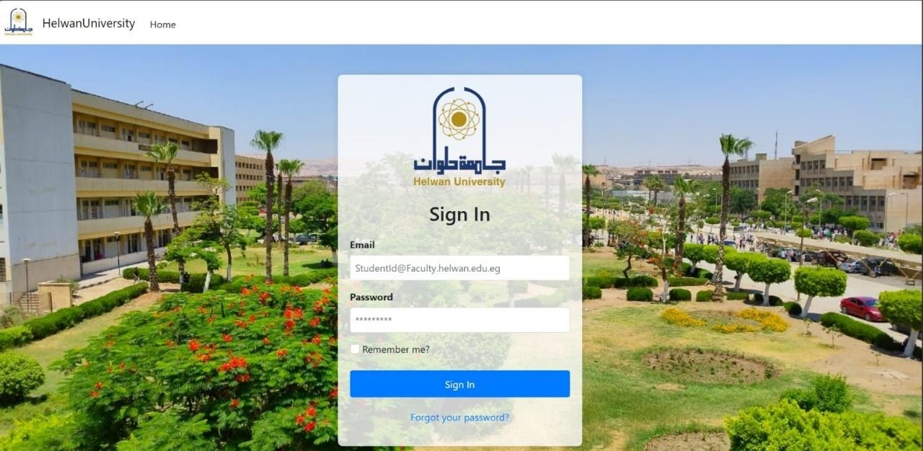
Figure 6.1.1: Login Page

This figure illustrates the secure login interface, which serves as the primary gateway for all authenticated users (students, doctors, high-board members, and administrators). It highlights the system's robust authentication mechanism, ensuring that only authorized individuals can access their respective portals. This directly addresses the security aspect of system access and provides a centralized entry point, improving user experience by streamlining the initial access process.


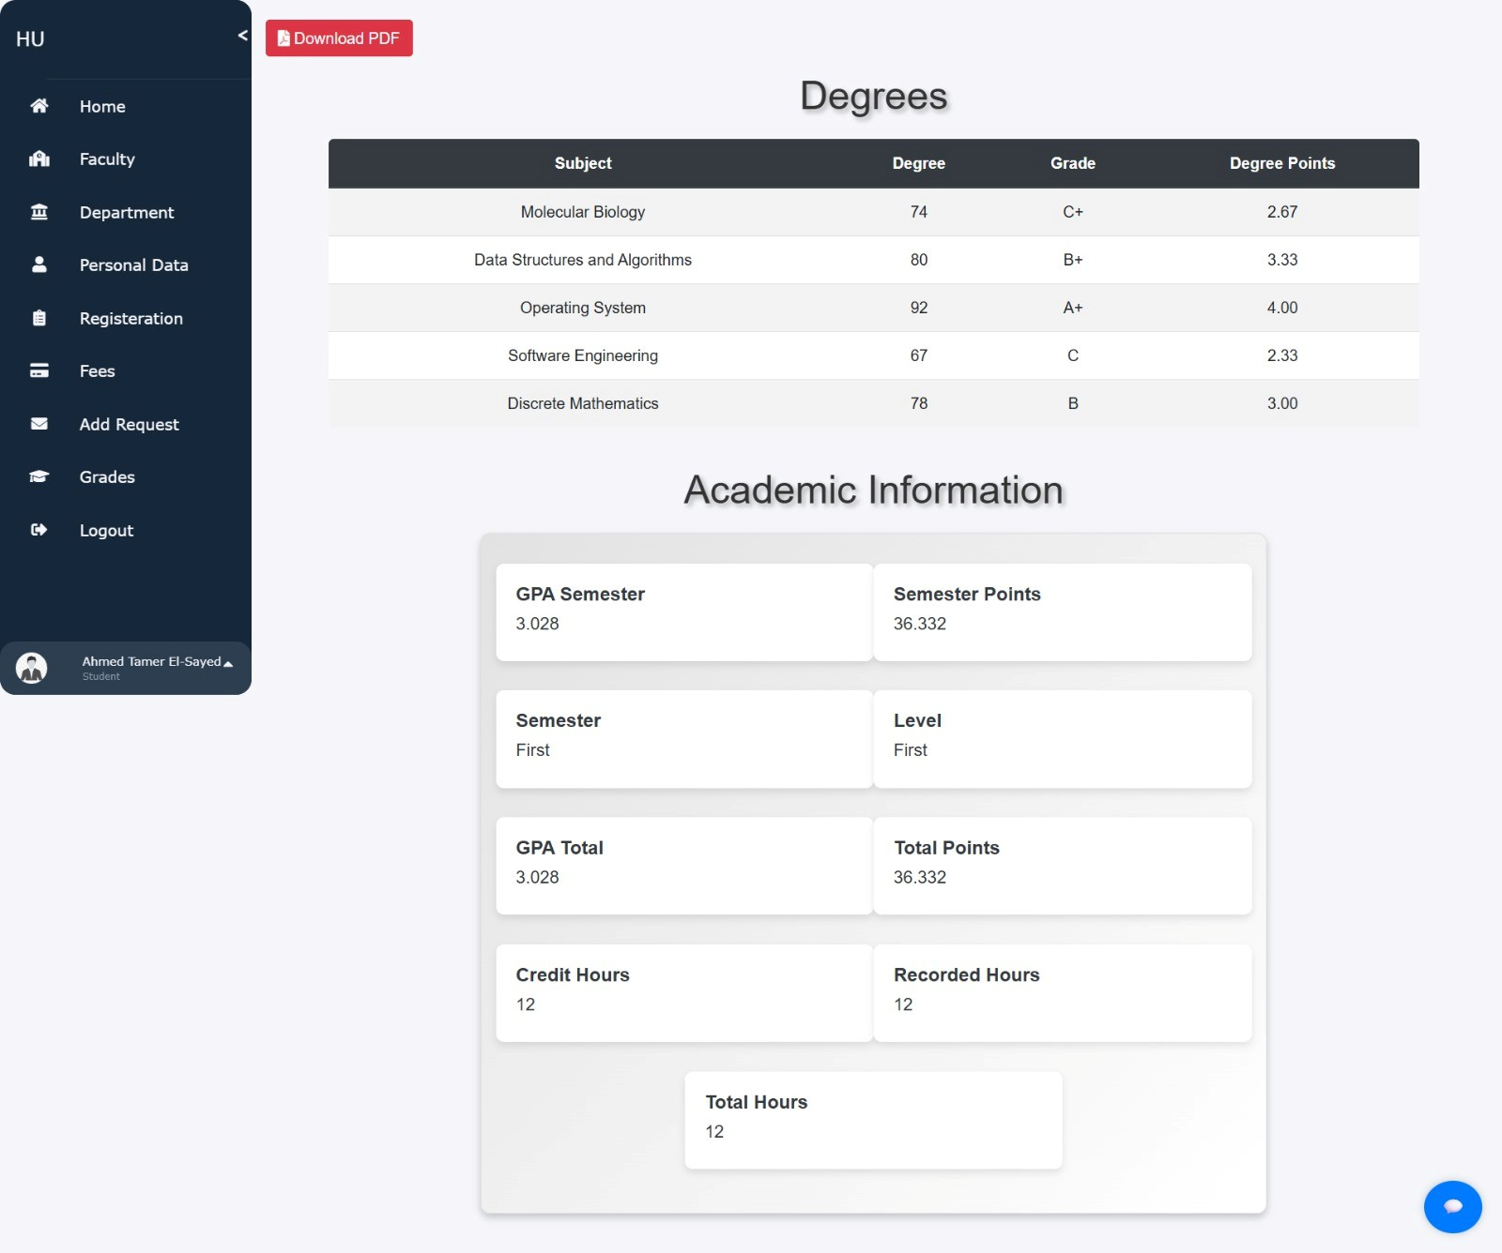
Figure 6.1.2.1: Student Portal Dashboard

Figure 6.1.2.2: Student Portal Dashboard Academic

This figure showcases the personalized dashboard available to logged-in students. It provides a quick overview of their profile and essential information. This functionality directly tackles the problem of lack of instant information access for students, empowering them with immediate visibility into their personal and academic data in a user-friendly format.

Figure 6.1.3: AI Attendance System (Live Recognition Phase)
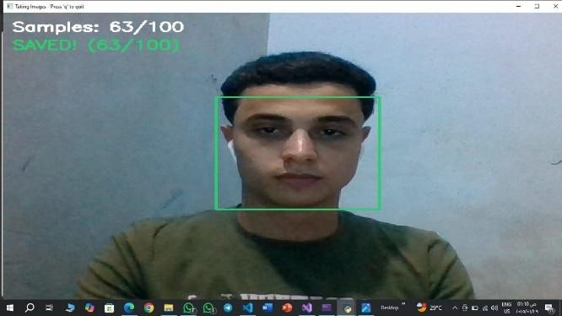
Figure 6.1.3: AI Attendance System (Live Recognition Phase)

This figure demonstrates the core of our AI-powered attendance solution in action. It captures the real-time facial recognition process, where the system detects and identifies a student, confirming their identity. This functionality directly solves the problem of inefficient manual attendance procedures, transforming a time-consuming and error-prone process into an automated, accurate, and efficient system. It also highlights the integration of advanced AI for practical administrative benefits.


Figure 6.1.4: Integrated Chatbot Interaction

This figure illustrates the intelligent AI chatbot integrated into the university's web platform. It shows how students can interact with the chatbot to get instant answers to their queries, and crucially, how the chatbot dynamically generates direct links to personalized information (e.g., a link to their grades page). This directly addresses the problem of instant information access and outdated communication channels, providing 24/7 support and reducing the administrative burden of repetitive inquiries.

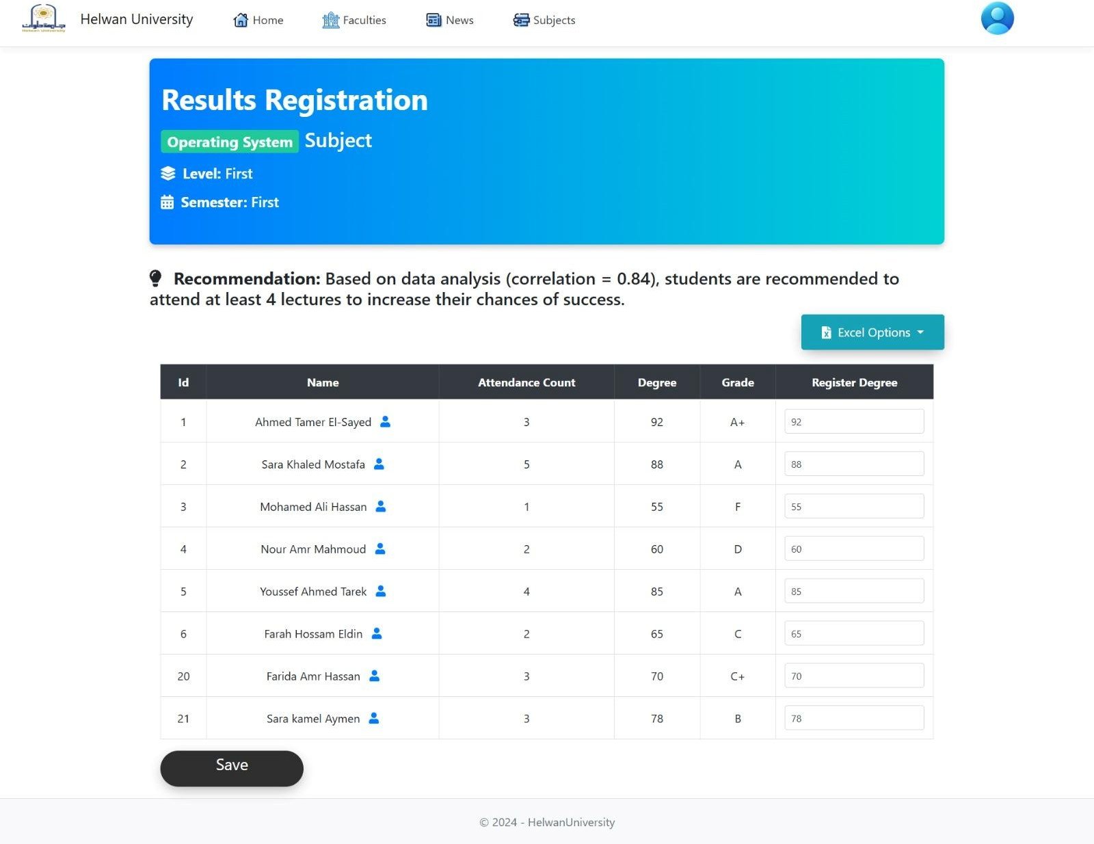
Figure 6.1.5: Student Grades Management (Doctor/High-Board Portal)
This figure presents the interface for managing student grades, accessible to authorized Doctors or High-Board members. It demonstrates the streamlined process of entering and updating grades, which automatically triggers academic calculations (GPA, level progression) in the backend. This directly enhances the efficiency of academic operations, replacing manual grading processes and ensuring real-time academic record accuracy.

This figure showcases the inte
Figure 6.1.6: Online Tuition Fee Payment Process
. By leveraging a secure

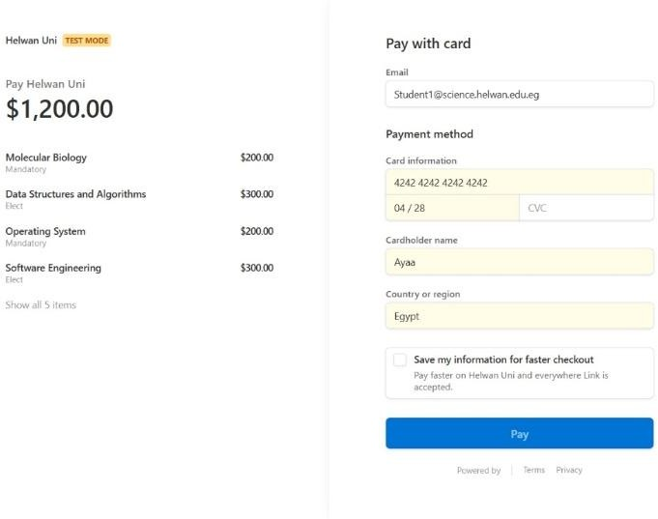
payment gateway, the system offers students a convenient and modern method to fulfill their financial obligations. This directly streamlines inefficient manual financial procedures and improves the overall student experience by providing a secure and accessible payment solution.
grated online tuition fee payment process
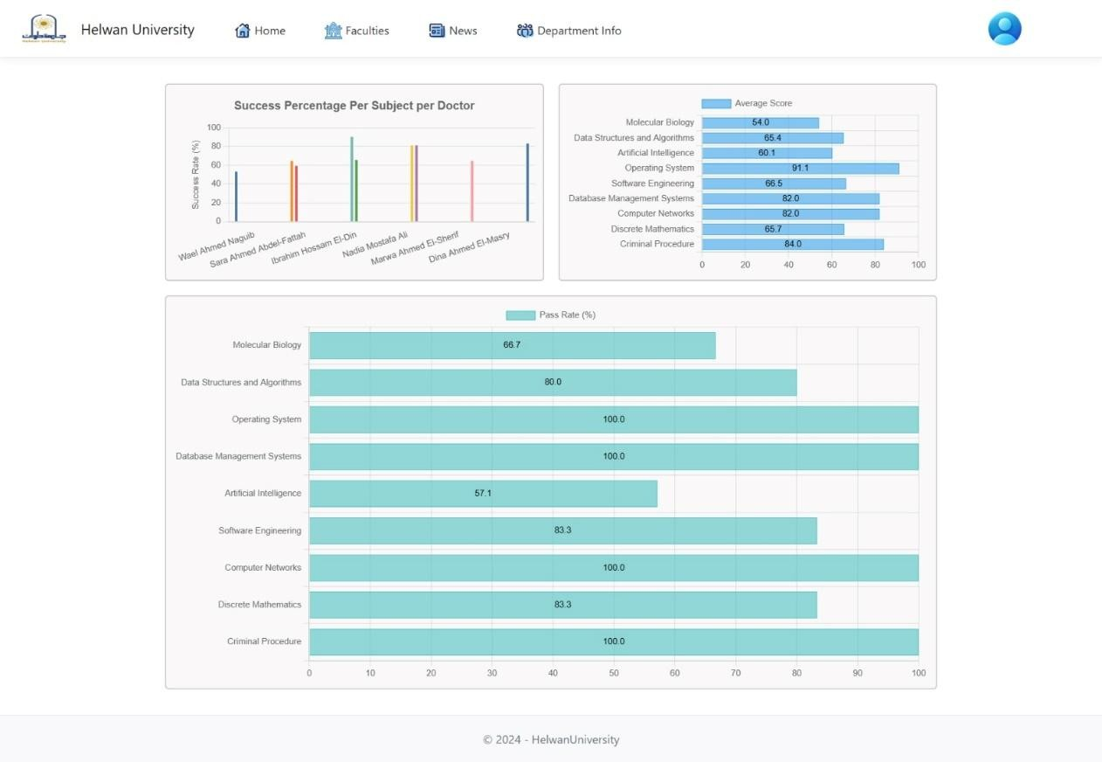
Figure 6.1.7: Academic Reports / Data Visualization
This figure highlights the system's capability to generate insightful academic reports and data visualizations. It transforms raw academic data into understandable charts and graphs, offering clear insights into student performance or departmental metrics. This directly addresses the problem of limited data insights for decision-making, empowering administration and faculty with tools for data-driven strategic planning and educational improvement.

6.1.8: Administrator - Student Management

Figure 6.1.8: Administrator - Student Management
This figure demonstrates the comprehensive student management module available to system administrators. It highlights the ability to efficiently browse, search, add, edit, and delete student profiles. This directly tackles the inefficiency of manual data management and provides administrators with centralized control over critical student information, improving data consistency and administrative workflows.

Project Objectives Achievement

This section revisits each specific objective outlined in Chapter 1.2 and discusses how the implemented functionalities and features of the Helwan University Smart Management System have successfully met these goals.

    - Objective 1: To automate and enhance student attendance tracking.

      - Achievement: This objective has been comprehensively met through the development and integration of an AI-powered facial recognition attendance system.
      - Demonstration: The system successfully captures student images in real-time, performs accurate facial recognition using trained models (SVM based on face_recognition encodings), and automatically logs attendance records directly into the central database. The process includes quality checks for captured images (blurriness, brightness) and confirmation frames for stable recognition.
      - Impact: This automation significantly reduces the administrative burden associated with manual attendance, minimizes errors, and provides real-time, verifiable attendance data, addressing the problem of inefficient manual operations.

    - Objective 2: To provide instant and intelligent student support.

      - Achievement: An intelligent AI chatbot has been successfully integrated into the university web platform, offering immediate support to students.
      - Demonstration: The chatbot operates using a hybrid model:
        - It prioritizes responses based on static rules, directly providing links to personalized information (e.g., grades, profile, registered subjects) within the student portal when specific keywords are detected.
        - For general university queries, it leverages an AI-powered RAG system (LangChain with Google Gemini Flash) to generate informative responses from a broad knowledge base.
        - A fallback mechanism (Keras/NLTK model) ensures responses even if the primary RAG service is unavailable.
        - The chatbot can be accessed as a convenient pop-up from any student portal page.
      - Impact: This dramatically improves student access to information, reduces response times for common inquiries, and alleviates the load on administrative staff, directly addressing the challenge of limited instant information access and outdated communication channels.

    - Objective 3: To streamline core academic and administrative operations.

      - Achievement: The project has successfully streamlined key academic and administrative operations through dedicated management modules and automated processes.
      - Demonstration:
        - Student Profile Management: Administrators can efficiently manage (add, view, edit, delete) student profiles, with automated fetching of student names from the university database upon ID input, ensuring data consistency.
        - Academic Records & Grading: Doctors and High-Board members can record and update student grades, which automatically triggers comprehensive academic calculations (GPA, level, semester progression, credit hours).
        - Faculty, Department, and Subject Management: Dedicated interfaces allow administrators and authorized High-Board members to manage the organizational structure of the university (faculties, departments) and academic offerings (subjects), including assigning subjects to departments and doctors.
      - Impact: This significantly reduces manual data entry, minimizes errors, enhances data consistency, and automates complex academic processes, thereby reducing administrative overhead and improving overall operational efficiency.

    - Objective 4: To enhance data accessibility and analytical capabilities.

      - Achievement: The system has centralized university data and provided intuitive tools for data visualization and reporting.
      - Demonstration:
        - All critical university data (student profiles, academic records, attendance logs, departmental structures) is stored in a centralized SQL Server database, ensuring a single source of truth.
        - The platform includes features for generating various academic reports and displaying interactive charts (e.g., GPA statistics by department, subject pass rates).
      - Impact: This transformation from disparate data sources to a centralized, easily accessible, and visually represented format addresses the problem of limited data insights, empowering administrators and faculty to make more informed, data-driven strategic decisions.

    - Objective 5: To integrate secure online payment solutions.

      - Achievement: A robust and secure online payment gateway has been successfully integrated to simplify tuition fee payments.
      - Demonstration: Students can initiate and process tuition fee payments directly through the system via the integrated Stripe payment gateway. The system handles the creation of secure checkout sessions and updates the student's payment status in the database upon successful completion.
      - Impact: This provides a convenient, secure, and efficient method for students to manage their financial obligations, streamlining a key administrative process and enhancing the student's overall experience.

Discussion of Results & Project Limitations

This section provides a comprehensive discussion of the project's findings, interpreting the outcomes achieved and acknowledging the current limitations that offer avenues for future enhancements.

General Discussion of Findings

The development and implementation of the Helwan University Smart Management System have yielded highly positive results, demonstrating the feasibility and significant impact of integrating intelligent technologies into university administration. The project successfully addressed the core challenges identified in Chapter 1 by:

      - Achieving Automation and Efficiency: The AI-powered facial recognition attendance system proved effective in automating student check-ins, significantly reducing manual effort and improving the accuracy of attendance records. This directly enhances administrative efficiency.
      - Enhancing Student Support and Accessibility: The integrated AI chatbot successfully provides instant, intelligent support to students, answering general queries and dynamically directing them to personalized information via direct links within the portal. This drastically improves information accessibility and student self-service.
      - Streamlining Core Operations: Modules for managing student profiles, academic records, subjects, departments, and faculties have streamlined key administrative and academic workflows. The automated calculation of GPA, grades, and academic progression upon grade entry ensures real-time accuracy and reduces manual workload.
      - Providing Data-Driven Insights: The system successfully centralizes diverse university data and presents it through intuitive visualizations and reports, empowering decision-makers with actionable insights into academic performance and operational efficiency.
      - Integrating Secure Financial Transactions: The successful implementation of online tuition fee payment via Stripe offers a secure and convenient financial solution for students.

Current Project Limitations

Despite the successful implementation and achievement of its core objectives, the Helwan University Smart Management System, in its current phase, operates with certain limitations that present clear opportunities for future development:

Limited Scope of Advanced AI Features:

      - Liveness Detection: The AI attendance system, for performance optimization on the current deployment environment, temporarily disables sophisticated liveness detection (anti-spoofing). This represents a potential security vulnerability against spoofing attacks.
      - Chatbot Depth: While intelligent, the chatbot's advanced capabilities (e.g., complex multi-turn dialogue management, sentiment analysis, voice integration) are not fully explored. Its knowledge base is primarily static (JSON files) and relies on a pre-trained model for specific intents, or external LLM for RAG.
      - Predictive Analytics: The system does not yet incorporate advanced predictive modeling for student performance forecasting or proactive intervention strategies.

Performance Optimization Opportunities (N+1 Queries):

      - While optimizations like eager loading were applied, certain data retrieval patterns in the Repositories (e.g., in DoctorRepository.GetDepartments, StudentRepository.ReturnDegrees, AcademicRecordsRepository.GetChartData, SubjectRepository.ReturnDegrees) still exhibit characteristics of the N+1 query problem. This can impact performance under high load or with very large datasets, requiring further refinement of database query strategies.
      - Environmental issues related to Python library compatibility (e.g., numpy/scipy, dlib) and NLTK data downloads, as well as CondaSSLError during setup, proved to be significant and time-consuming challenges. While resolved for the current setup, robust deployment strategies are needed for production environments.
      - Scalability Assessment: Formal load testing was not conducted, which means the system's precise performance metrics and behavior under extreme concurrent user loads are not empirically validated in the current phase.
      - User Interface & Accessibility: While designed for user-friendliness, extensive user testing for a wide range of accessibility needs beyond standard practices was not performed.
      - Mobile Application: The project currently operates as a web-based platform.
      - Manual Data Entry for AI Training: The initial process of collecting and verifying student facial images for AI model training still involves manual oversight and data management in local CSVs.

Chapter 7: Conclusion & Future Work

Conclusion

The Helwan University Smart Management System represents the successful culmination of a comprehensive project aimed at modernizing and optimizing core university operations through the strategic integration of intelligent technologies. This project has not only achieved its ambitious objectives but has also laid a robust foundation for a more efficient, secure, and user-centric educational environment.

Key Accomplishments and Contributions

The project's primary accomplishments and contributions include:

      - Development of a Comprehensive Platform: Successfully designed and implemented a unified web-based system using ASP.NET Core MVC that centralizes various administrative and academic functionalities.
      - Pioneering AI Integration: Implemented an automated facial recognition-based attendance system, drastically improving efficiency and accuracy over traditional methods.
      - Enhanced Student Support: Developed and integrated an intelligent AI chatbot that provides instant, dynamic support to students, answering queries and directing them to personalized information within the portal.
      - Streamlined Operations: Automated academic calculations (GPA, grades, level progression) and streamlined management of student profiles, subjects, departments, and faculties, significantly reducing administrative overhead.
      - Secure Payment Solution: Integrated a robust online payment gateway (Stripe) for secure and convenient tuition fee processing, enhancing financial efficiency.
      - Data-Driven Insights: Centralized disparate data and provided intuitive reporting and visualization tools, enabling more informed decision-making for university administration.
      - Robust Security & Authorization: Implemented a multi-layered security model with role-based access control and granular permissions, ensuring data integrity and user accountability through activity logging.
These accomplishments directly address the problems of inefficiency, limited information access, and fragmented systems, providing a cohesive and intelligent solution that enhances operational fluidity and enriches the user experience.

Lessons Learned

The implementation journey of this project provided invaluable insights and learning experiences, highlighting the complexities and best practices in building integrated intelligent systems:

      - Importance of Meticulous Environment Management: Technical challenges related to Python library compatibility (e.g., NumPy/SciPy), NLTK data downloads, and dlib installation issues underscored the critical need for meticulous environment setup and dependency management in multi-language projects.
      - Database Query Optimization: The frequent encounter with the N+1 query problem emphasized the necessity of proactive database query optimization, particularly through eager loading and efficient data projection, for ensuring application performance and scalability.
      - Robust API Design & Error Handling: The integration of diverse APIs (C# to Python, Stripe, Cloudinary) highlighted the importance of designing resilient API endpoints and implementing comprehensive error handling mechanisms for network issues, data mismatches, and external service failures.
      - Trade-offs in AI Implementation: Decisions regarding AI model complexity versus real-time performance (e.g., disabling liveness detection for speed) illustrated the practical trade-offs often required in AI system development, necessitating careful consideration of priorities.
      - Value of Iterative Development & Testing: The project benefited significantly from an iterative development approach, allowing for continuous testing and refinement based on user feedback and the resolution of encountered challenges.
      - Complexity of Granular Authorization: Implementing fine-grained, hierarchical authorization rules based on user roles and specific entities (e.g., faculty, department) was complex but essential for a secure and functional university system.

These lessons learned will serve as crucial guidelines for future software development endeavors, particularly in the realm of intelligent systems and complex integrations.

Future Work

The current implementation of the Helwan University Smart Management System provides a robust foundation for modern university administration. However, software development is an iterative process, and several key enhancements and new features have been identified for future versions to further improve the system's capabilities, performance, and user experience.

Enhanced AI Attendance System:

- Comprehensive Liveness Detection: Integrate advanced anti-spoofing and liveness detection mechanisms into the facial recognition system to prevent fraudulent attendance logging via photos or videos. This will significantly bolster the security and integrity of attendance records.
- Optimized AI Model Deployment: Further optimize the facial recognition models (e.g., using specialized hardware like Nvidia Jetson or Google Coral Edge TPU) for even faster processing and improved performance on embedded devices, ensuring near-instantaneous recognition.

Expanded Chatbot Capabilities:

- Advanced Dialogue Management: Enhance the chatbot to handle more complex, multi-turn conversations and maintain context across a session, allowing for more natural and fluid interactions.
- Voice Integration: Implement voice input and output capabilities to provide an alternative interaction method for students, enhancing accessibility and convenience.
- Deeper University Data Integration: Allow the chatbot to directly query and retrieve diverse types of real-time university data (e.g., specific course schedules, exam dates, classroom availability) from the database, beyond just providing static links, to offer more immediate answers.
- Sentiment Analysis: Integrate sentiment analysis to understand the emotional tone of student queries, enabling the chatbot to respond more empathetically or escalate critical issues to human support.

Dedicated Mobile Application:

- Develop a full-featured cross-platform mobile application (e.g., using Flutter) for iOS and Android devices. This would provide students and faculty with seamless access to essential system functionalities (e.g., viewing profiles, grades, attendance, news, chatbot) on the go, significantly enhancing accessibility and user convenience.

Advanced Data Analytics & Predictive Modeling:

- Implement advanced analytical modules to identify trends in student performance, attendance patterns, and course engagement.
- Develop predictive models to forecast student success rates, identify at-risk students, or optimize resource allocation based on historical data.

E-Learning Platform Integration:

- Integrate the system with existing or new e-learning platforms (LMS) to synchronize course content, assignments, and grades, providing a more unified academic experience for students and faculty.

Real-time Notifications & Alerts:

- Implement a robust notification system to send real-time alerts to students (e.g., important announcements, grade updates, payment reminders) and faculty/admin (e.g., attendance anomalies, critical student issues) via email, SMS, or in-app notifications.

Enhanced Security Measures:

- Explore and implement additional security protocols, including more sophisticated two-factor authentication options, intrusion detection systems, and regular security audits to protect sensitive university data.

Performance Optimization for Production Scale:

- Conduct comprehensive load testing and performance benchmarking in a production-like environment to identify and resolve any bottlenecks under high user concurrency and large data volumes. This would involve further optimizing database queries, implementing caching strategies, and fine-tuning server configurations.

DevOps Automation:

- Automate environment setup and dependency management for both ASP.NET Core and Python components for easier development and deployment workflows.

References:
This section lists all sources cited or referenced in the development of the Helwan University Smart Management System and its accompanying documentation.
- Faculty of Science Helwan University. (2023). Graduation Project Student Guidelines. Helwan University.
- Team of Previous Project. (2023). Graduation Project Documentation: Full Automated Security System Based On Deep Learning Technology.
- Helwan University.Anaconda. Anaconda Distribution Documentation. Available at: https://docs.anaconda.com.
- FastAPI. FastAPI Documentation. Available at: https://fastapi.tiangolo.com.
- Google Cloud. Google Generative AI Documentation (Vertex AI, Google AI Studio). Available at: https://cloud.google.com/vertex-ai/docs/generative-ai.
- Microsoft. ASP.NET Core Documentation. Available at: https://docs.microsoft.com/en-us/aspnet/core.
- NLTK. NLTK Documentation. Available at: https://www.nltk.org.
- OpenCV. OpenCV Documentation. Available at: https://docs.opencv.org.
- Microsoft. .NET Documentation. Available at: https://learn.microsoft.com/en-us/dotnet.
- Stripe. Stripe Docs. Available at: https://stripe.com/docs.
- Scikit-learn. Scikit-learn Documentation. Available at: https://scikit-learn.org/stable.
- SciPy. SciPy Documentation. Available at: https://docs.scipy.org/doc/scipy/reference.
- TensorFlow. TensorFlow Documentation. Available at: https://www.tensorflow.org.
- W3C. The WebSocket API. Available at: http://www.w3.org/TR/websockets.
- Chart.js. Chart.js Documentation. Available at: https://www.chartjs.org/docs/latest.

